Welcome to this week’s school office newsletter!
Here are some of the latest updates, reminders, and key moments…
🌟 This Week’s Highlights
Willow Family Cafe
Parents joined Willow Class for a busy Phonics café of fun activities, games and crafts. We noticed that everyone enjoyed trying to find all the bugs and insects, including the spiders and frogs! We look forward to hearing about the inspiration the cafe will gave the children to share their reading with their families.
Oak Family Cafe
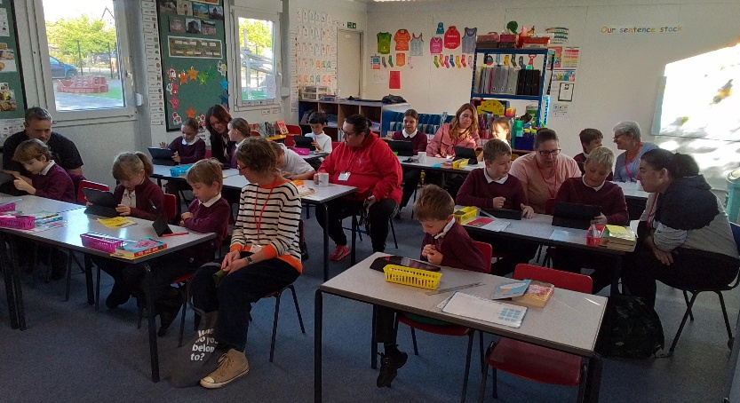
Oak Class were delighted to welcome parents and grandparents to our class on Thursday. The children confidently shared their Roger McGough inspired poems that we have been working on in our writing lessons. Then, with excellent contributions from our adults, the children wrote poems inspired by 'A Book Speaks'. In the original poem, a book is given a voice and tells the reader how to care for it and be a good friend to it. In our cafe, we were challenged to give a voice to an inanimate object.
Oak Class Poetry!
Below are just three of the many excellent examples that were created by Oak Class:
Tree
When it's windy, my branches wave
Even in a storm, I am brave
As my leaves fall, they dance to the ground
Falling so lightly, not making a sound

Crystal
I am a crystal, don't mine so hard
You want me whole, not as a shard
My glacial light will shine so bright
If your hammer blows are nice and slight

Chair
Life as chair can feel static
But at least I'm not in the attic
Supporting you while you rest
I don't like to be a pest

📅 Important Dates
- Monday 5th October - Parents Evening.
- Thursday 8th October – Journeys For Learning — We are pleased to welcome back the Journeys for Learning team for another interactive day of learning.
- Friday 9th October – Do Blue! — Children are invited to come to school in their blue clothes, in return for a donation to the MIND charity.
📢 Important Reminders
- Harvest Assembly on Monday 5th October - Please bring any food donations to school on Monday. See attached leaflet for information.
- Aspens will be here on Monday 5th October to demonstrate their smoothie maker and food tasting. Parents are welcome to arrive a little earlier than their booked parents evening appointment and enjoy making a smoothie!
📌 Coming Up
Looking ahead, we are excited about a second EYFS Open Event on 15th October and showing new families around our school. Everyone did an amazing job talking about our school to new families who visited on Tuesday this week.
Thank you, as always, for your continued support.
Warm regards,

