


WHOLE SCHOOL POLICY FOR SAFEGUARDING
INCORPORATING CHILD PROTECTION
POLICY
Document Control:
Document Author: | Daniel Halls
Approval Body: | SET Trustees | Date: 03.08.2026
Version Number: | 7
Version Issue Date: | 03.08.2026 | Effective Date: | 01.09.2026
Review Frequency: | Annually (or in line with updates to statutory guidance
Method of Dissemination: | Electronic publication to membership
For Use By: | All staff, visitors, and Trustees

Version History:
Version | Date | Author | Reason
V1 | 19.07.2022 | Daniel Halls | Changes to Statutory guidance (KCSIE 2022)
V2 | 04.01.2023 | Daniel Halls | Changes to procedures under 12. Managing allegations against staff, supply staff, trainee teachers, volunteers and contractors
V3 | 01.07.2023 | Daniel Halls | Reviewed and updated in line with updated KCSIE 2023.
V4 | January 2024 | Daniel Halls | Reflect updates to PREVENT guidance and Working Together to Safeguard Children 2023
V5 | 01.09.2024 | Michelle Atkinson | Annual review and updated in line with KCSIE 2024
V6 | 01.09.2025 | Michelle Atkinson | Annual review and updated in line with KCSIE 2025
V7 | 01.09.2026 | Michelle Atkinson | Annual review and updated in line with KCSIE 2026

Contents
1. PURPOSE & AIMS 2
2. OUR ETHOS 4
3. ROLES AND RESPONSIBILITIES 5
4. TRAINING & INDUCTION 10
5. PROCESSES AND PROCEDURES 11
6. SPECIFIC SAFEGUARDING ISSUES 13
7. SAFER RECRUITMENT 21
8. SAFER WORKING PRACTICE 22
9. MANAGING ALLEGATIONS AGAINST STAFF, SUPPLY STAFF, TRAINEE TEACHERS, VOLUNTEERS & CONTRACTORS AND LOW-LEVEL CONCERNS 23
10. VISITING SPEAKERS AND USE OF PREMISES FOR NON-SCHOOL ACTIVITIES 25
11. RELEVANT POLICIES 26
12. STATUTORY FRAMEWORK 26
APPENDICES 28
Annex 1: REPORTING FORM FOR SUPPLY STAFF, VOLUNTEERS & VISITORS 27
Annex 2: SAFEGUARDING INDUCTION SHEET FOR SUPPLY STAFF, VOLUNTEERS AND VISITORS. 30
Annex 3: LOCAL SAFEGUARDING PROCEDURES 32
ANNEX 4: MYCONCERN REPORTING SYSTEM 34

PURPOSE & AIMS
For the purposes of this policy, all references to “our school” should be understood to mean Burston & Tivetshall Primary Schools. This terminology is used throughout the document for consistency and applies to the whole school community, including pupils, staff, trustees, volunteers, visitors, and parents/carers.
The purpose of our school safeguarding policy is to ensure every child who is a registered pupil at our school is safe and protected from harm. This means we will always work to:
- Protect children and young people at our school from maltreatment.
- Prevent impairment of our children’s and young people’s health or development.
- Ensure that children and young people at our school grow up in circumstances consistent with the provision of safe and effective care.
- Undertake that role so as to enable children and young people at our school to have the best outcomes.
This policy applies to, and will give clear direction to, all staff, supply staff, volunteers, visitors, Trustees (throughout this policy they will be referred to as ‘adults’), and parents/carers about expected behaviour and our legal responsibility to safeguard and promote the welfare of all children at our school. ‘Children’ includes everyone under the age of 18.
Our school fully recognises the contribution it can make to protect children from harm and to support and promote the welfare of all children who are registered pupils at our school.
We use the terms “must” and “should” throughout the policy. We use the term “must” when the person in question is legally required to do something and “should” when the advice set out should be followed unless there are exceptionally good reasons not to.
This policy is applicable to all students registered at the school.
This policy should be read alongside the following DfE documents:
- All staff, including staff who do not work directly with children, will read Part One and Part 5 of Keeping Children Safe in Education 2026 in full.
- The Department for Education’s Part One overview may be used as a supplementary quick-reference resource, but it does not replace the requirement to read Part One.
- The Designated Safeguarding Lead and deputy DSLs will read the guidance in full, including Annex B concerning the role of the Designated Safeguarding Lead.
- statutory guidance Working together to safeguard children - GOV.UK
- departmental advice What to do if you are Worried a Child is Being Abused - Advice for Practitioners;
and our own policies including:
- The behaviour policy (which includes measures to prevent bullying, including cyberbullying, prejudice-based and discriminatory bullying, and the school’s response to harmful sexual behaviour)
- Staff code of conduct
- Attendance policy (including safeguarding response to children who are absent from education particularly on repeat occasions and/or for prolonged periods.)
- Safe use of technology policy

OUR ETHOS
The child’s welfare is of paramount importance. Our school will establish and maintain an ethos where pupils feel secure, are encouraged to talk, are listened to and are safe. Children at our school will be able to talk freely to any ‘adult’ at our school if they are worried or concerned about something. All ‘adults’ will reassure victims that they are being taken seriously and that they will be supported and kept safe. The school adopts a zero-tolerance approach to sexual violence and sexual harassment and victims will never be given the impression that they are creating a problem by reporting abuse, sexual violence, or sexual harassment.
All ‘adults’ who come into contact with students and their families have a role to play in safeguarding students. We recognise that staff at our school play a particularly important role as they are in a position to identify concerns early and provide help and support to meet the needs of the child as soon as they emerge. All staff should maintain an attitude of ‘it does happen here’ where safeguarding is concerned. When concerned about the welfare of a child, whether that is within or outside the home, including online, staff members must always act in the best interests of the child.
We ensure that safeguarding and child protection is at the forefront and underpins all relevant aspects of process and policy development. We operate with the best interests of the child at heart.
The systems we have in place are well promoted, easily understood and easily accessible for children to confidently report abuse, knowing their concerns will be treated seriously, and knowing they can safely express their views and give feedback.
Throughout our broad and balanced curriculum, we will provide activities and opportunities for children to develop the knowledge, values, and skills they need to identify risks, including knowing when and how to ask for help for themselves and others to stay safe (this includes online). The Relationships Education, Relationship and Sex Education and Health Education (delivered in regularly timetabled lessons and reinforced throughout the whole curriculum) will cover relevant topics in an age and stage appropriate way, through a planned, developmental curriculum enabling pupils to learn about their rights and responsibilities to behave and stay safe in a variety of contexts on and offline. This will provide further reinforcement to help children identify risks, know when to seek support and develop the skills to ask for help from trustworthy, reliable sources. Further information can be found in the DfE guidance ‘Teaching online safety in school.’ and ‘Relationships Education, Relationships and Sex Education and Health Education.’

Across Key Stage 1 & 2
Who I am | Sex education | Online safety
Relationships | Healthy me and changing me | Road safety
Dreams and goals | Celebrating differences | Water safety
Introduction to first aid | Mental health
We will work in partnership and endeavour to establish effective working relationships with parents, carers and colleagues from other agencies in line with Working Together to Safeguard Children (2026) and Norfolk Safeguarding Partnership.
The school recognises that children and families may benefit from support at different levels, including universal services, community-focused early help and targeted Family Help. Staff will identify emerging needs at the earliest opportunity and share concerns with the DSL.
These may include if a child:
- is disabled or has certain health conditions and has specific additional needs.
- has special educational needs (whether or not they have a statutory education, health, and care plan).
- has a mental health need.
- is a young carer.
- is showing signs of being drawn in to anti-social or criminal behaviour, including gang involvement and association with organised crime groups.
- is frequently missing/goes missing from care or from home.
- is at risk of modern slavery, trafficking, sexual or criminal exploitation.
- is at risk of being radicalised or exploited.
- has a family member in prison or is affected by parental offending.
- is in a family circumstance presenting challenges for the child, such as substance abuse, adult mental health problems or domestic abuse.
- is misusing drugs or alcohol themselves.
- has returned home to their family from care.
- is at risk of ‘honour’-based abuse such as Female Genital Mutilation or Forced Marriage.
- is a privately fostered child.
- is persistently absent from education, including persistent absences for part of the school day.
- Financial exploitation
- Child to parent/carer abuse
We recognise our responsibilities and understand the importance of working in line with:
- The Equalities Act 2010
- The Human Rights Act 1998
- Public Sector Equality Duty
This means we do not unlawfully discriminate against pupils because of their sex, race, disability, religion or belief, gender reassignment, pregnancy and maternity, or sexual orientation (protected characteristics).

ROLES AND RESPONSIBILITIES
Role | Name | Contact details
Designated Safeguarding Lead (DSL) | Burston – Sally Underwood  Tivetshall – Tom Henry | s.underwood@bps.set.education  01379 741256  t.henry@tps.set.education  01379 677350
Senior Mental Health Lead | Sally Underwood | s.underwood@bps.set.education  01379 741256
Deputy DSL | Karen Millar (B&T)  Molly Cattermole (T)  Christine North (B) | k.millar@shs.set.education  m.cattermole@tps.set.education  c.north@bps.set.education
Executive Headteacher | Karen Millar | k.millar@shs.set.education  01379 384387 / 07384810456
Named Safeguarding Trustee | Roger Margand | clerk@setrust.co.uk
Chair of the Sapientia Education Trust | Peter Rout | clerk@setrust.co.uk
SET Director of Safeguarding and Attendance | Michelle Atkinson | m.atkinson@setrust.co.uk
It is the responsibility of every ‘adult’ in our school to ensure that they carry out the requirements of this policy and, at all times, work in a way that will safeguard and promote the welfare of all of the pupils at this school. This includes the responsibility to provide a safe environment in which children can learn.
Where there is a safeguarding concern, the DSL and other adults in school will ensure the child’s wishes and feelings are considered when determining what action to take and what services to provide. The DSL and Trustees will ensure that systems are in place and well promoted, easily understood and easily accessible for children to confidently report abuse, knowing their concerns will be treated seriously, and knowing they can safely express their views and give feedback.
The Board of Trustees
The Board of Trustees at Sapientia Education Trust is accountable for ensuring the effectiveness of this policy and our compliance with it. Trustees will ensure they facilitate a whole school and Trust approach to safeguarding. This means ensuring safeguarding and child protection is at the forefront and underpins all relevant aspects of process and policy development. Although the Trustees take collective responsibility to safeguard and promote the welfare of our pupils, we also have a named Trustee Roger Margand who champions safeguarding across the Trust.
The Board of Trustees will ensure that:
- The safeguarding policy is in place and is reviewed annually (as a minimum) and updated if needed, so that it is kept up to date with safeguarding issues as they emerge and evolve, including lessons learnt, available publicly via our school website and has been written in line with Local Authority guidance and the requirements of the Norfolk Safeguarding Partnership.
- The safeguarding and child protection policy is effective by
  - reflecting the whole school/college approach to child-on-child abuse, the recognition of it and the different forms it may take.
  - reflecting reporting systems
  - describing procedures which are in accordance with government guidance.
  - referring to locally agreed multi-agency safeguarding arrangements put in place by the safeguarding partners.
  - being reviewed annually (as a minimum) and updated if needed, so that it is kept up to date with safeguarding issues as they emerge and evolve, including lessons learnt.
  - being available publicly either via the school or college website or by other means.
- The school has a behaviour policy which includes measures to prevent bullying (including cyberbullying, prejudice-based and discriminatory bullying) and the use of mobile phones during the school day.
- The Trust has a staff code of conduct in place which should, amongst other things, include acceptable use of technologies (including the use of mobile devices), staff/pupil relationships and communications including the use of social media.
- The school has appropriate safeguarding arrangements in place to respond to children who go missing from education, particularly on repeat occasions.
- The school contributes to inter-agency working in line with Working Together to Safeguard Children (2026).
- A senior member of staff from the leadership team is designated to take the lead responsibility for safeguarding and child protection and that there is at least one Deputy Designated Safeguarding Lead (DDSL) who is an appropriately trained member to deal with any issues in the absence of the Designated Safeguarding Lead (DSL). There will always be cover for this role (in term time and during school or college hours). The role will be evidenced explicitly in the role holder’s job description.
- All staff receive a safeguarding induction before commencing work and are provided with a copy of this policy, Part One and Annex B of KCSIE, the staff code of conduct, the behaviour policy and the school’s safeguarding response for those pupils who are routinely absent from education as detailed in section 6 of this policy.
- All staff undertake appropriate safeguarding and child protection (including online safety) training that is updated annually.
- Procedures are in place for dealing with allegations against members of staff, supply staff, trainee teachers, volunteers, and contractors in line with statutory and SET guidance.
- Safer recruitment practices are followed in accordance with the requirements of ‘KCSIE 2026’
The Trustees (via the Education committee) will receive a safeguarding update from each school, at least 3 times a year, as part of the Head Teacher’s report.
The Sapientia Education Trust
The Sapientia Education Trust will ensure that:
- This policy is effectively implemented through the Trust’s safeguarding strategy.
- regular quality assurance activities are completed at all school to assess the effectiveness of the school’s safeguarding arrangements.
- Headteacher and DSLs are provided with a written report containing actions and recommendations to ensure safeguarding requirements are met.
- Ongoing safeguarding training is made available to DSLs and ADSLs.
- DSLs, DDSLs and HTs are supported in their roles.
- DSLs and DDSLs are part of the Sapientia DSL Network
- Remedy without delay any weakness in regard to our safeguarding arrangements that are brought to their attention.
Sapientia Education Trust Safeguarding team has the right to access individual pupil safeguarding files for the purpose of quality assurance, support, guidance, and direction.
The Headteacher
The Headteacher is responsible for:
- Identifying a senior member of staff from the leadership team to be the Designated Safeguarding Lead (DSL).
- Identifying alternate members of staff to act as the Deputy Designated Safeguarding Lead (DDSL) in his/her absence to ensure there is always cover for the role (term time and during school hours).
- Ensuring that the policies and procedures adopted by the school, particularly concerning referrals of cases of suspected abuse and neglect, are followed by all staff.
- Ensuring that all staff and volunteers feel able to raise concerns about poor or unsafe practice and such concerns are addressed sensitively in accordance with agreed whistle-blowing procedures.
- Liaise with the LADO in the event of an allegation of abuse being made against a member of staff, supply staff or volunteer.
The Designated Safeguarding Leads (DSL)
- The Designated Safeguarding Lead is a senior member of staff, from the leadership team who takes lead responsibility for safeguarding and child protection within our school. The DSL will carry out their role in accordance with the responsibilities outlined in Annex B of ‘KCSIE 2026’.
- The DSLs and DDSLs will undergo suitable training, including Prevent training, to equip them with the skills and knowledge required to undertake their role, which will be updated at a minimum every two years; in addition, their skills and knowledge will be refreshed at regular intervals, annually at a minimum. This includes accessing e-courier and disseminating national and local updates to staff, attendance at DSL cluster/forum meetings, monthly online safety newsletter, signed up to safeguarding newsletters. All training will be in line with Norfolk Safeguarding Partnership. All training will be in line with Norfolk Safeguarding Partnership.
- The DSL will provide advice and support to other staff on child welfare and child protection matters. Any concern for a child’s safety or welfare will be recorded using MyConcern (see Annex 4)
- During term time the DSL and/or a DDSL will always be available (during school or college hours) for staff in the school to discuss any safeguarding concerns. If in exceptional circumstances, a DSL is not available on the school site in person, we will ensure that they are available via telephone and/or any other relevant media. Alternatively, contact can be made with the SET Director of Safeguarding and Attendance – Michelle Atkinson.
- The DSL will regularly provide staff, pupils, parents, and carers with signposting information for reporting safeguarding concerns out of school hours and during school holidays.
- The DSL or DDSLs will represent our school at child protection conference, core group meetings and other meetings. They will liaise with Children’s Services and other agencies where necessary.
- The DSL or DDSLs will make referrals to Children’s Services and other agencies when required.
- The DSL and DDSLs will maintain up to date records and child protection files ensuring that they are kept confidential and stored securely using MyConcern.
- The DSL will ensure all adults undergo appropriate safeguarding training, to give them the necessary skills and knowledge to perform their safeguarding duties.
- The DSL is responsible for ensuring that all staff members, supply staff and volunteers are aware of our policy and the procedure they need to follow.
- Work with those who are responsible for attendance, behaviour and SEND within the school.
- The DSL and DDSLs will work with the headteacher and senior leaders, taking lead responsibility for promoting educational outcomes by knowing the welfare, safeguarding and child protection issues that children in need are experiencing, or have experienced, and identifying the impact that these issues might be having on children’s attendance, engagement, and achievement.
- The DSL and DDSLs are aware of the requirement for children to have an appropriate adult when in contact with Police officers who suspect them of an offence, as outlined in the Police and Criminal Evidence Act (1984) – Code C.

The appropriate adult’ means, in the case of a child:
- the parent, guardian or, if the juvenile is in the care of a local authority or voluntary organisation, a person representing that authority or organisation.
- a social worker of a local authority
- failing these, some other responsible adult aged 18 or over who is not:
  - a Police officer.
  - employed by the police.
  - under the direction or control of the chief officer of a police force; or
  - a person who provides services under contractual arrangements (but without being employed by the chief officer of a police force), to assist that force in relation to the discharge of its chief officer’s functions,
PACE states that anyone who appears to be under 18, shall, in the absence of clear evidence that they are older, be treated as a child for the purposes of the code.
PACE also states that If at any time an officer has any reason to suspect that a person of any age may be vulnerable, then that person is entitled to be accompanied by an appropriate adult at any point.
The Designated Safeguarding Lead (DSL) will communicate any vulnerabilities known by the school to any police officer who wishes to speak to a pupil about an offence they may suspect. This communication will be recorded on MyConcern.
If having been informed of the vulnerabilities, the designated safeguarding lead (or deputy) does not feel that the officer is acting in accordance with PACE, they should ask to speak with a supervisor or contact 101 to escalate their concerns.
A person whom there are grounds to suspect of an offence must be cautioned before questioned about an offence, or asked further questions if the answers they provide the grounds for suspicion, or when put to them the suspect’s answers or silence, (i.e., failure or refusal to answer or answer satisfactorily) may be given in evidence to a court in a prosecution.
A Police Officer must not caution a juvenile or a vulnerable person unless the appropriate adult is present. If a child or a vulnerable person is cautioned in the absence of the appropriate adult, the caution must be repeated in the appropriate adult’s presence.
Further information can be found in the Statutory guidance - PACE Code C 2019.

TRAINING & INDUCTION
Every new member of staff, supply staff, contractor or volunteer will receive safeguarding training before contact with students at the school. This programme will include information relating to signs and symptoms of abuse, how to manage a disclosure from a child (including reassuring victims that they are being taken seriously and that they will be supported and kept safe), how to record, the processes for referral to Children’s Services and the statutory assessments under Section 17 and Section 47 as well as the remit of the role of the Designated Safeguarding Lead (DSL). The training will also include information about raising concerns about another adult’s behaviour and suitability to work with children. Staff will also receive online safety training as this is part of the overarching safeguarding approach of our school. They will be given copies of the documents outlined above, which they are required to read and sign to say they have read and understood these key documents via MyConcern. They will also be provided with information on how to complete a referral on MyConcern.
In addition to the safeguarding induction, we will ensure that mechanisms are in place to assist staff to understand and discharge their role and responsibilities as set out in Part one of ‘KCSIE 2026’. In order to achieve this, we will ensure that:
- all members of staff will undertake appropriate safeguarding training on an annual basis, and we will evaluate the impact of this training.
- all staff members receive regular safeguarding and child protection updates (for example, via email, e-bulletins, staff meetings), as required, but at least annually, to provide them with relevant skills and knowledge to safeguard children effectively.
- all staff have read and signed all policies and statutory documents at induction and when they are updated.
- Standing item for staff meetings
- Regular updates on staffroom noticeboard

All regular visitors, supply staff, temporary staff and volunteers to our school will be given a copy of our safeguarding procedures; they will be informed of whom our DSL and DDSLs are and what the recording and reporting system is. (See Annex 2 & 3).
Our Trustees will also undertake appropriate safeguarding training at induction and updated annually to ensure they are able to carry out their duty to safeguard all of the children at our school. Training for Trustees to support them in their safeguarding role is provided by the Trust.

PROCESSES AND PROCEDURES
When ‘adults’ become concerned about the welfare of a child, they should always act in the best interests of the child and have a responsibility to act as outlined in this policy.
All ‘adults’ are required to report any concerns that they have regardless of the severity on MyConcern. Any ‘adult’ at the school who identifies that a child may be or is at risk of harm must report it immediately to the DSL or DDSL. In the absence of either of the above, the matter should be brought to the attention of the most senior member of staff. It is not the responsibility of school staff to investigate welfare concerns or determine the truth of any disclosure or allegation.
We recognise that not all children may feel ready to or know how to tell an adult that they are being abused. Staff and other key adults are made aware of this key point and encouraged to report any concerns which they have.
All concerns about a child or young person, including child-on-child abuse, should be reported, and recorded on MyConcern without delay and before the end of the working day. The record should include:
  - a clear and comprehensive summary of the concern
  - details of how the concern was followed up and resolved.
  - a note of any action taken, decisions reached and the outcome.
A concern being raised will be reviewed promptly and proportionately, and the DSL or DDSLs will determine what action is required. Serious safeguarding concerns will be reviewed immediately and, where required, referred to Children's Services and/or Police without delay. All information and actions taken, including the reasons for any decisions made, will be fully documented. The child’s wishes, and feelings should always be considered when determining what action to take and what services to provide.
Where the school identifies that students and their families need support, they will follow the referral procedures outlined by Norfolk Safeguarding Partnership. Further information is available in Annex 3.
If, at any point, there is a risk of immediate serious harm to a child a referral should be made to Norfolk Safeguarding Partnership. and/or the police immediately. The DSL or DDSL should also be informed as soon as possible.
Any disagreements between the referrer and the receiving agency will be appropriately voiced and discussed, with the referrer following appropriate escalation procedures. If the referrer continues to remain dissatisfied and if the circumstances warrant. Any disagreements or escalation will be recorded in writing by the referrer and shared with the relevant agency. A record of all disagreements and escalations should be recorded and stored on MyConcern.
Staff should always follow the reporting procedures outlined in this policy in the first instance. However, they may also share information directly with Norfolk Safeguarding Partnership. or the police if:
- the situation is an emergency, and the child is in imminent danger.
- the situation is an emergency and the designated safeguarding lead, their Deputy and the Headteacher are all unavailable.
- they are convinced that a direct report is the only way to ensure the pupil’s safety.
Any member of staff who does not feel that concerns about a child have been responded to appropriately and in accordance with the procedures outlined in this policy should raise their concerns with the DSL in the first instance. If any member of staff does not feel the situation has been addressed appropriately at this point, they should then raise it with the Headteacher, alternatively, staff can contact the SET Director of Safeguarding and Attendance, Michelle Atkinson and/or Norfolk Safeguarding Partnership directly with their concerns.
We are committed to working in partnership with parents/carers to safeguard and promote the welfare of children and to support them to understand our statutory responsibilities in this area.
We will seek to share with parents any concerns we may have about their child unless to do so may place a child at increased risk of harm. A lack of parental engagement or agreement regarding the concerns the school has about a child will not prevent the DSL making a referral to Norfolk Children’s Services in those circumstances where it is appropriate to do so.

In order to keep children safe and provide appropriate care for them, the school requires parents to provide accurate and up to date information regarding:
- Full names and contact details of all adults with whom the child normally lives.
- Full names and contact details of all persons with parental responsibility (if different from above).
- Emergency contact details (if different from above).
- Full details of any other adult authorised by the parent to collect the child from school (if different from the above).
- Copies of any court order that affects parental responsibility and or care of a child.
Any paper files received will be kept in a separate named file, in a secure cabinet and not with the child’s academic file. These files will be the responsibility of the DSL. Child protection information will only be shared within school on the basis of ‘need to know in the child’s best interests’ and on the understanding that it remains strictly confidential. When a child leaves our school, (including in year transfers) the DSL will contact the DSL at the new school and will ensure that the child protection file is forwarded to the receiving school separately from the main pupil file. This will be within 5 days for an in-year transfer or within the first 5 days of the start of a new term. We will retain evidence to demonstrate how the file has been transferred; this may be in the form of a written confirmation of receipt from the receiving school and/or evidence of recorded delivery. Where a parent elects to remove their child from the school roll to home educate, the school will make arrangements in line with Norfolk procedures regarding the sharing and retention of safeguarding information. In addition, the school will follow the SET guidance for children leaving in year and ensure the family are supported and all options have been discussed with the family.
Prior to a child leaving we will consider if it would be appropriate to share any additional information with the new school or college in advance to help them put in place the right support to safeguard this child.
Information sharing is vital in identifying and tackling all forms of abuse and neglect, and in promoting children’s welfare, including their educational outcomes. We, as a school have clear powers to share, hold and use information for these purposes.
The Data Protection Act 2018 and UK GDPR do not prevent the sharing of information for the purposes of keeping children safe. Fears about sharing information must not be allowed to stand in the way of the need to safeguard and promote the welfare and protect the safety of children.
We will refer to the further guidance below as needed, on the sharing of information:
- Chapter one of Working Together to Safeguard Children
- Information Sharing: Advice for Practitioners Providing Safeguarding Services to Children, Young People, Parents and Carers.
- The Information Commissioner’s Office (ICO)
- Data protection: toolkit for schools

SPECIFIC SAFEGUARDING ISSUES
Part One of Keeping Children Safe in Education must be read by all staff. It provides further information on types of abuse as well as toolkits, advice and support covering several specific safeguarding issues.

Contextual safeguarding/Extra-Familial Harm

We recognise that safeguarding incidents and/or behaviours can be associated with factors outside of the school or home environment and/or can occur between children outside of the school. This is known as contextual safeguarding. It is key that all school staff are aware of the definition of contextual safeguarding/extra-familial harm and consider whether children are at risk of abuse or exploitation in situations outside their families.
When reporting concerns, staff should include as much information and background detail as possible so the DSL can make a referral with a holistic view of the child. This will allow any assessment to consider all the available evidence and the full context of any abuse.
We will work with local partners, including Social Care and Police, to ensure that we stay alert to any emerging contextual risks, and to ensure that assessment of risk for any of our pupils includes appropriate reference to their local community and environment.

LGB and gender-questioning children

The school recognises that children who are lesbian, gay or bisexual, or who are questioning their sexual orientation or gender, may experience additional vulnerabilities, including bullying, abuse, family conflict, isolation or online harm. Staff will provide a safe and respectful environment, listen to the child’s views, consider their individual circumstances and follow safeguarding procedures where concerns arise. Decisions will be child-centred, lawful and informed by current statutory guidance

Child Sexual Exploitation (CSE) Child Criminal Exploitation (CCE): County Lines and serious violence

We recognise that Child Sexual Exploitation and Child Criminal Exploitation are forms of abuse and both occur where an individual or group takes advantage of an imbalance in power to coerce, manipulate or deceive a child into sexual or criminal activity in exchange for something the victim needs or wants, and/or for the financial advantage or increased status of the perpetrator or facilitator and/or through violence or the threat of violence. Whilst age may be the most obvious, this power imbalance can also be due to a range of other factors including gender, sexual identity, cognitive ability, physical strength, status, and access to economic or other resources. CSE and CCE can affect children, both male and female. Victims can be exploited even when the activity appears consensual, and it should be noted exploitation as well as being physical can be facilitated and/or take place online or through the use of technology.

We also note that the experience of girls who are criminally exploited can be very different to that of boys. The indicators may not be the same, however we are aware that girls are at risk of criminal exploitation too. We understand that both boys and girls being criminally exploited may be at higher risk of sexual exploitation.

We understand that County Lines represents drug networks or gangs that groom and exploit children and young people to carry drugs and money from one location to another. Key to identifying potential involvement in county lines are missing episodes when the victim may have been trafficked for the purpose of transporting drugs.

We know that there are indicators which may signal children are at risk from, or are involved with serious violent crime, including County Lines. These may include increased absence from school, a change in friendships or relationships with older individuals or groups, a significant decline in performance, signs of self-harm or a significant change in wellbeing, or signs of assault or unexplained injuries. Unexplained gifts or new possessions could also indicate that children have been approached by, or are involved with, individuals associated with criminal networks or gangs and may be at risk of criminal exploitation.

The school recognises the wider context of violence affecting children, including risks associated with weapons, harmful online influences, misogyny, incedl-related beliefs, and violence against women and girls. Staff will remain alert to emerging concerns and understand the importance of early identification and intervention to prevent risks from escalating. We recognise that serious violence may overlap with criminal or sexual exploitation, absence from education and other forms of extra-familial harm; therefore, concerns will be considered holistically, taking account of the child’s relationships, experiences, online activity, attendance and wider community context.
A concern about a weapon, threat of violence or credible online threat is reported immediately to the DSL and, where there is immediate danger, to the police.

So-called ‘honour-based abuse (including Female Genital Mutilation and Forced Marriage

We recognise that our staff are well placed to identify concerns and take action to prevent children from becoming victims of Female Genital Mutilation (FGM) and other forms of so-called ‘honour-based’ abuse (HBA) and provide guidance on these issues through our safeguarding training. If staff have a concern regarding a child that might be at risk of HBA, they should inform the DSL who will activate local safeguarding procedures, using existing national and local protocols for multiagency liaison with police and children’s social care.

Section 5B of the Female Genital Mutilation Act 2003 (as inserted by section 74 of the Serious Crime Act 2015) places a statutory duty upon teachers in England and Wales, to report to the police where they discover (either through disclosure by the victim or visual evidence) that FGM appears to have been carried out on a girl under 18. Those failing to report such cases will face disciplinary sanctions. We will provide guidance and support to our teachers on this requirement and further information on when and how to make a report can be found in the following Home Office guidance: Mandatory Reporting of Female Genital Mutilation- procedural information Home Office (December 2015)
We recognise that forcing a person into a marriage is a crime in England and Wales. A forced marriage is one entered into without the full and free consent of one or both parties where violence, threats or any other form of coercion is used to cause a person to enter into a marriage. Threats can be physical or emotional and psychological. The Forced Marriage Unit has statutory guidance and Multi-agency guidelines and can be contacted for advice or more information: Contact 020 7008 0151 or email fmu@fco.gov.uk. In addition, since February 2023 it has also been a crime to carry out any conduct whose purpose is to cause a child to marry before their eighteenth birthday, even if violence, threats, or another form of coercion are not used. As with the existing forced marriage law, this applies to non-binding, unofficial ‘marriages’ as well as legal marriages.
Domestic abuse

Domestic abuse can encompass a wide range of behaviours and may be a single incident or a pattern of incidents. That abuse can be, but is not limited to, psychological, physical, sexual, financial, or emotional and can occur between partners and ex-partners. We understand that experiencing, hearing, and witnessing domestic abuse poses a significant risk to children and understand the detrimental impact experiences of this nature has on children, including the long-term impact on a child’s physical and mental health and learning. Children who experience domestic abuse are recognised as victims in their own right within the law. It is also important to note that domestic abuse may occur between two children in their own intimate relationships.

At our school we are working in partnership with Norfolk Constabulary and Norfolk Children’s Services to identify and provide appropriate support to pupils who have experienced domestic violence in their household; this scheme is called Operation Encompass. In order to achieve this, Norfolk police & Norfolk local authority will share police information of all domestic incidents where one of our pupils has been present with the Designated Safeguarding Lead(s). On receipt of any information, the Designated Safeguarding Lead will decide on the appropriate support the child requires, this could be silent or overt. All information sharing and resulting actions will be undertaken in accordance with the Norfolk police & Norfolk Local Authority protocol. We will record this information and store this information in accordance with the record keeping procedures outlined in this policy.

Preventing radicalisation and extremism

We recognise that safeguarding against radicalisation and extremism is no different to safeguarding against any other vulnerability in today’s society. We will ensure that:
- Through training, staff, volunteers, and Trustees understand what radicalisation and extremism is, why we need to be vigilant in school and how to respond when concerns arise.
- There are systems in place for keeping pupils safe from extremist material when accessing the internet in our school by using effective filtering, monitoring and usage policies.
- Members of the safeguarding team have received additional training on extremism and radicalisation. They will act as the point of contact within our school for any concerns relating to radicalisation and extremism.
- Complete a Prevent risk assessment, to identify to risks faced by the community and put in place appropriate control measures.
- The DSL will make referrals in accordance with Norfolk procedures and will represent our school at Channel meetings as required. A decision will be made on the necessity of gaining an individual consent prior to make the referral, this will be based on a dynamic risk assessment completed by the DSL.
- Build resilience through our curriculum, by supporting students to have the knowledge, skills and values that will prepare them to be citizens in modern Britain. This will include promoting fundamental British values.
- Helping students to build resilience to radicalisation and extremism.
- Foster a safe environment for debate and helping students to influence and participate in decision making.
- Assess the suitability and effectiveness of external speakers who are invited into the school.
- Complete the appropriate checks on all non-school groups and organisations who use our school premises. The use will be monitored and in the event of any behaviour not in line with our expectations will result in termination of the agreement and referrals made to the relevant authorities.

Child-on-child abuse (including harassment and violence)

We recognise that children are also vulnerable to physical, sexual, and emotional abuse by their peers, another child, or siblings.

All staff are trained so that they are aware that safeguarding issues can manifest themselves via child-on-child abuse. This is most likely to include, but may not be limited to:
- bullying (including cyberbullying, prejudice-based and discriminatory bullying); abuse in intimate personal relationships between peers.
- physical abuse such as hitting, kicking, shaking, biting, hair pulling, or otherwise causing physical harm (this may include an online element which facilitates, threatens and/or encourages physical abuse).
- sexual violence, including rape, assault by penetration and sexual assault, which may include an online element that facilitates, threatens or encourages sexual violence.
- sexual harassment, such as sexual comments, remarks, jokes, and online sexual harassment, which may be standalone or part of a broader pattern of abuse.
- causing someone to engage in sexual activity without consent, such as forcing someone to strip, touch themselves sexually, or to engage in sexual activity with a third party.
- consensual and non-consensual making or sharing of nudes and semi nudes’ images and or videos. We will refer to and apply the UKCIS guidance in circumstances where nudes and or semi nudes have been shared.
- upskirting, which typically involves taking a picture under a person’s clothing without their permission, with the intention of viewing their genitals or buttocks to obtain sexual gratification, or cause the victim humiliation, distress, or alarm; and
- initiation/hazing type violence and rituals (this could include activities involving harassment, abuse or humiliation used as a way of initiating a person into a group and may also include an online element).

We understand that even if there are no reports of child-on-child abuse in our setting it does not mean it is not happening, it may be the case that it is just not being reported. The school recognises that misogynistic, sexist or degrading language and behaviour can form part of a continuum of harm and may escalate if it is not identified and addressed at an early stage. Such behaviour will not be dismissed as banter or an inevitable part of growing up.
Staff will challenge and report these behaviours in accordance with the behaviour and safeguarding procedures. Responses will be proportionate, child-centred and informed by an assessment of the needs and vulnerabilities of all children involved.

All staff will understand that they should follow our safeguarding procedures for reporting a concern if they are worried about child-on-child abuse. The DSL will respond to any concerns related to child-on-child abuse in line with statutory guidance. We will ensure that all concerns, discussions, and decisions reached are clearly recorded and any identified actions are followed up.

All staff will reassure victims that they are being taken seriously and that they will be supported and kept safe. Victims will never be given the impression that they are creating a problem by reporting abuse, sexual violence, or sexual harassment. Nor will a victim ever be made to feel ashamed for making a report. We will also offer appropriate support to the perpetrator and any other children involved.

Modern Slavery

We understand that modern slavery encompasses human trafficking and slavery, servitude and forced or compulsory labour. Exploitation can take many forms, including sexual exploitation, forced labour, slavery, servitude, forced criminality and the removal of organs. We refer to the DfE guidance Modern slavery: How to identify and support victims for concerns of this nature.
Children who are absent from education
All staff should be aware of the safeguarding responsibilities for children who are absent from education, particularly on repeat occasions, to help identify the risk of abuse and neglect, including sexual abuse or exploitation, and to help prevent the risks of their going missing in future.
In line with statutory guidance, Working Together to Improve School Attendance 2025, schools must work with children's services where the school absence indicates a safeguarding concern​.
We adhere to the following procedures and processes to ensure there is an appropriate safeguarding response to children who are absent:
- An attendance register is taken at the start of the first session of each school day and once during the second session.
- We make every effort to contact parents and carers and follow up with the emergency contacts held.
- We hold at least two emergency contact numbers for each of the pupils on our roll wherever possible.
- Staff will alert DSLs to any concerns raised regarding children who are absent from school.
- The DSLs will meet regularly with the Attendance Lead, SENDCo and other members of the pastoral team to ensure that each response is thorough and considers all the relevant information about individual children.
- We will follow the procedures outlined in our attendance policy including undertaking first day calling and monitoring data to ensure we intervene early in cases of poor attendance and/or unexplained absences.
- When removing a child from roll at the standard and non-standard transition points, we will inform the Local Authority in accordance with statutory requirements to prevent a student becoming a child missing from education.
- In line with our attendance policy every effort will be made to contact the family through letter, emails, phone calls and home visits, both planned and unannounced.
- Where contact is made, families are invited to meet with the school to discuss any concerns they may have. This could include SLT, EWO/AEO, Class teacher or appropriate member of support staff.

Mental health

Mental health problems can, in some cases, be an indicator that a child has suffered or is at risk of suffering harm. All staff are well placed to observe children day-to-day and identify those whose behaviour suggests that they may be experiencing a mental health problem or be at risk of developing one. It is key that staff are aware of how suffering abuse and neglect, or other potentially traumatic adverse childhood experiences, can impact on their mental health, behaviour, and education. If any member of staff has a mental health concern about a child that is also a safeguarding concern, immediate action should be taken, following the safeguarding procedures as outlined in this policy.
We have a named Senior Mental Health Lead in our school. There are clear systems and processes in place for identifying possible mental health problems and work with other agencies as required to respond to these concerns.

Children who need a Social Worker

We recognise that children who need a social worker may need this help due to abuse, neglect and complex family circumstances. Staff will be aware that a child’s experiences of adversity and trauma can leave them vulnerable to further harm, as well as educationally disadvantaged in facing barriers to attendance, learning, behaviour, and mental health. The DSL will use information from the local authority to inform decisions about safeguarding (for example, responding to unauthorised absence or missing education where there are known safeguarding risks) and promoting welfare. (For example, considering the provision of pastoral and/or academic support, alongside action by statutory services). The DSL will liaise with relevant staff and outside agencies to monitor progress, achievement and to ensure that the child receives appropriate support. Where students have social worker, they may fall under the remit of the Norfolk Virtual School. We work alongside the Virtual School to track, monitor and support students. This can include additional tuition, support with extracurricular activities, behaviour interventions etc. Children with a social worker are a standing agenda item for pupil progress meetings, attendance monitoring and SLT meetings.

Online Safety

Technology is a significant component in many safeguarding and wellbeing issues experienced by children. We understand that in many cases abuse will take place concurrently via online channels and in daily life. We know that children can also abuse their peers online; this can take the form of abuse, harassment, the non-consensual sharing of nude or semi-nude images, especially around chat groups, and the sharing of abusive images and pornography.
The breadth of issues classified within online safety is considerable, but can be categorised into four areas of risk:
- content: being exposed to illegal, inappropriate, or harmful content, for example: pornography, fake news, racism, misogyny, self-harm, suicide, anti-Semitism, misinformation, disinformation, conspiracy theories, radicalisation, and extremism.
- contact: being subjected to harmful online interaction with other users; for example: child-on-child pressure, commercial advertising and adults posing as children or young adults with the intention to groom or exploit them for sexual, criminal, financial or other purposes.
- conduct: personal online behaviour that increases the likelihood of, or causes, harm; for example, making, sending, and receiving explicit images (e.g., consensual, and non-consensual making or sharing of nudes and semi-nudes and/or pornography, sharing other explicit images and online bullying; and
- commerce - risks such as online gambling, inappropriate advertising, phishing and or financial scams. If we feel our pupils, students or staff are at risk, we will report it to the Anti-Phishing Working Group (https://apwg.org/).

Digital Risk and Artificial Intelligence (AI)
In line with Keeping Children Safe in Education 2026, we recognise the emerging safeguarding risks associated with digital technology, including the use of generative artificial intelligence (AI). We will ensure that staff, pupils and parents are aware of both the opportunities and potential risks presented by AI, such as exposure to misinformation, disinformation, and harmful content. The school recognises that generative AI may be used to create, alter or distribute harmful, abusive or misleading content, including realistic fabricated images of children. Such material will be treated as a safeguarding concern regardless of whether an original image existed or whether the content was wholly or partly generated using AI.

Our approach will be informed by the Department for Education’s guidance, including the Plan Technology for Your School tool, to support safe and effective use of digital technologies. We will review our filtering, monitoring and digital literacy education at least annually to ensure it reflects the latest developments in online risk, including the safe and ethical use of AI. The review, findings, actions, and completion dates will be recorded.

As part of the requirement for staff to undergo regular updated safeguarding training, online safety training is also delivered as part of the annual safeguarding training. We will ensure online safety is a running and interrelated theme throughout the curriculum and is reflected in relevant policies, teacher training, the role and responsibilities of the designated safeguarding lead and any parental engagement.

At our school we use Smoothwall for filtering and Senso for monitoring to protect pupils while they are online on a school device, during school hours. These systems are routinely monitored by appropriate trained staff and will flag concerns when they are identified. The school will review the effectiveness of its filtering and monitoring arrangements at least annually and whenever there is a significant change to technology, provision or identified risk. This information is used to inform a whole school approach to online safety. More details can be found in our Safe use of technology policy.

We recognise that technology, and risks and harms related to the internet evolve and change rapidly. Therefore, we carry out an annual review of our approach to online safety, supported by a risk assessment (on at least an annual basis) that considers and reflects the risks that children face in our setting.

Parents have an important role to play in protecting their children from potential harm they may experience while online. We will routinely share resources and provide information to parents on these harms.

The Trustees will regularly monitor the effectiveness of our filtering and monitoring systems, using the DFE’s Filtering and Monitoring standards as a benchmark. They will ensure all ‘adults’ at the school:
- Receive appropriate online safety training.
- Aware of and understand the systems used in school to monitor and filter the students use of technology.
- Manage them effectively, using the information to inform their whole school response to online safety.
- Can articulate what action they should take when a concern is identified.

Young Carers
The school recognises that young carers may experience hidden or unmet needs affecting their welfare, attendance, mental health and educational outcomes. Staff will be alert to indicators that a child is undertaking substantial or inappropriate caring responsibilities and will refer concerns to the DSL so that appropriate support can be considered.

Children with special educational needs and disabilities or physical health issues
We recognise that children with special educational needs or disabilities (SEND) or certain health conditions can face additional safeguarding challenges such as
  - assumptions that indicators of possible abuse such as behaviour, mood and injury relate to the child’s condition without further exploration.
  - these children being more prone to peer group isolation or bullying (including prejudice-based bullying) than other children.
  - the potential for children with SEND or certain medical conditions being disproportionally impacted by behaviours such as bullying, without outwardly showing any signs; and
  - communication barriers and difficulties in managing or reporting these challenges.

We work to address these additional challenges and consider extra pastoral support and attention for these children, along with ensuring any appropriate support for communication is in place. Staff will remain professionally curious and will not assume that an injury, change in behaviour or presentation is explained by a child’s medical condition. Safeguarding concerns will be reported to the DSL in accordance with this policy.
.
We also recognise that pupils who attend Alternative Provision will often have complex needs and due to this we are aware of the additional risk of harm these children may be vulnerable to.

SAFER RECRUITMENT
At all times the Headteacher and Trustees will ensure that safer recruitment practices are followed in accordance with the requirements of ‘KCSIE 2026. We will ensure that at least one member of all interview panels has completed appropriate safer recruitment training.

We will use the recruitment and selection process to deter and reject unsuitable candidates from applying for or securing employment, or volunteering opportunities.

- We will undertake Disclosure and Barring Service checks and other pre-employment checks as outlined in ‘KCSIE 2026’ and our Resourcing Policy to ensure we are recruiting and selecting the most suitable people to work with our children. As part of the shortlisting process, we will consider carrying out an online search on shortlisted candidates. Candidates will be informed that online searches may be undertaken as part of due diligence to identify matters that are publicly available and may be relevant to their suitability to work with children. Any concerns identified will be explored with the candidate and considered in accordance with safeguarding, employment and data-protection requirements.

In line with the Crime and Policing Act 2026 and the removal of the supervision exemption, volunteer roles will be assessed to determine whether they constitute regulated activity and require an enhanced DBS check with or without barred-list information.

We will maintain a Single Central Register (SCR) of all safer recruitment checks carried out in line with statutory requirements. A senior member of staff will check the SCR regularly to ensure that it meets statutory requirements.

When commissioning Alternative Provision (AP), we will follow the safeguarding expectations set out in Keeping Children Safe in Education 2026. The school remains responsible for safeguarding and includes:
- Assessing the placement’s suitability before commissioning;
- Obtaining and review the provider’s safeguarding policy;
- Confirming the identity and location of the provider;
- Recording the exact site attended;
- Agreeing attendance-notification arrangements;
- Ensuring concerns and allegations are reported promptly;
- Monitoring the pupil’s welfare, attendance and views;
- Visiting and quality-assuring the provision;
- Acting immediately where a placement becomes unsafe.
These measures ensure that safeguarding responsibilities remain consistent and robust, even when pupils are educated in off-site provision.

When arranging sport and extra-curricular activities, we will ensure that coaches and providers are appropriately checked; that changing, transport, photography, communication and one-to-one coaching arrangements are safe; and that all concerns are reported through the school’s safeguarding procedures.

SAFER WORKING PRACTICE
All adults who come into contact with our children have a duty of care to safeguard and promote their welfare. There is a legal duty placed upon us to ensure that all adults who work with or on behalf of our children are competent, confident, and safe to do so. All ‘adults’ will be provided with a copy of the Trust’s Code of Conduct at induction. They will also receive a copy of ‘Guidance for Safer Working Practices for Adults who work with Children and Young People in Education Settings’ (February 2022), which provides additional guidance. All staff, supply staff and volunteers are expected to carry out their work in accordance with this guidance and will be made aware that failure to do so could lead to disciplinary action.

MANAGING ALLEGATIONS AGAINST STAFF, SUPPLY STAFF, TRAINEE TEACHERS, VOLUNTEERS & CONTRACTORS AND LOW-LEVEL CONCERNS
Our aim is to provide a safe and supportive environment which secures the wellbeing and very best outcomes for the children at our school. We do recognise that sometimes the behaviour of adults may lead to an allegation of abuse being made. All concerns whether perceived as low level or not, should be reported as outlined in this policy.

Allegations sometimes arise from a differing understanding of the same event, but when they occur, they are distressing and difficult for all concerned. We also recognise that many allegations are genuine and there are some adults who deliberately seek to harm or abuse children. We work to the thresholds for harm as set out in ‘Working Together to Safeguard Children’ (2026) and ‘Keeping Children Safe in Education’, DfE (2026) below. An allegation may relate to a person who works / volunteers with children who has:
  - behaved in a way that has harmed a child or may have harmed a child and/or.
  - possibly committed a criminal offence against or related to a child and/or.
  - behaved towards a child or children in a way that indicates he or she may pose a risk of harm to children; and/or
  - behaved or may have behaved in a way that indicates they may not be suitable to work with children.

The 4th bullet point above recognises circumstances where a member of staff (including supply teachers) or volunteer is involved in an incident outside of school/college which did not involve children but could have an impact on their suitability to work with children; this is known as transferrable risk.

We recognise our responsibility to report / refer allegations or behaviours of concern and / or harm to children by adults in positions of trust who are not employed by the school (this includes individuals / organisations using the school premises) to the LADO.

We will take all possible steps to safeguard our children and to ensure that the adults in our school are safe to work with children. We will always ensure that the procedures outlined in the SET guidance for safeguarding complaints against adults, Norfolk Local Authority local protocol and Part 4 of ‘KCSIE 2026’ are adhered to and will seek appropriate advice. The first point of contact for schools regarding LADO issues is via the Norfolk Local Authority Duty Desk on 0344 800 8021. A Duty Advisor will give advice and guidance on next steps. If the advice is to make a referral to LADO, then the LADO referral form should be completed and submitted online. See annex 3 for further details.

If an allegation is made or information is received about any adult who works or volunteers in our setting which indicates that they may be unsuitable to work with children, the member of staff receiving the information should inform the Headteacher immediately. This includes concerns relating to agency and supply staff and volunteers. Should an allegation be made against the Headteacher, this will be reported to the SET CEO. In the event that the SET CEO is not contactable on that day, the information must be passed to, and dealt with by the SET Director of HR.

The Headteacher, SET CEO or SET Director of HR will seek advice from the LADO within 24 hours of the concern being raised. No member of staff will undertake further investigations before receiving advice from the LADO. A risk assessment will also be undertaken to determine if the individual(s) work duties need amending. If an allegation is made against a member of an external organisation, the organisation will be fully involved in any enquiries from the LADO, police and/or children social services.

Any member of staff or volunteer who does not feel confident to raise their concerns with the Headteacher, SET CEO or SET Director of HR should contact the LADO directly. Further national guidance can be found at: Advice on whistleblowing. The NSPCC whistleblowing helpline is also available for staff who do not feel able to raise concerns regarding child protection failures internally. Staff can call: 0800 028 0285 – line is available from 8:00am to 8:00pm, Monday to Friday or via e-mail: help@nspcc.org.uk

The school has a legal duty to refer to the Disclosure and Barring Service anyone who has harmed, or poses a risk of harm, to a child, or if there is reason to believe the member of staff has committed one of a number of listed offences, and who has been removed from working (paid or unpaid) in regulated activity or would have been removed had they not left. The DBS will consider whether to bar the person. If these circumstances arise in relation to a member of staff at our school, a referral will be made as soon as possible after the resignation or removal of the individual in accordance with advice from the LADO and/or HR. The Trust’s CEO will also consider whether to refer the case to the Secretary of State (via the Teaching Regulation Agency) if a teacher is dismissed or the setting ceases to use the services of a teacher if a teacher is dismissed or the setting ceases to use the services of a teacher because of serious misconduct or might have dismissed them or ceased to use their services had they not left first.

Concerns that do not meet the harm threshold.

The term ‘low-level’ concern does not mean that it is insignificant, it means that the behaviour towards a child does not meet the thresholds as stated above. Our process is to consult all concerns, regardless of perceived level of concern, with Norfolk Local Authority. We promote an open and transparent culture in which all concerns about all adults working in or on behalf of the school or college (including supply teachers, volunteers, and contractors) are dealt with promptly and appropriately.

We understand the importance of recording low-level concerns and the actions taken considering these being reported and follow the SET guidance for safeguarding concerns against an adult. The records are kept confidential and stored securely, in line with the SET guidance for safeguarding concerns against an adult. We will review the records we hold to identify potential patterns and act where appropriate. This could be through a disciplinary process (in line with the disciplinary policy) but also by referring to the Norfolk Local Authority Education Duty Desk on 0344 800 8021. Where a child, parent/carer or staff member makes an allegation of harm, this will not be considered as a ‘low level’ concern without consultation with Norfolk directly and in line with SET guidance for safeguarding concerns against an adult.

We recognise that low level concerns should not be included in references unless they relate to issues which would normally be included in a reference, for example, misconduct or poor performance. However, where a low-level concern (or group of concerns) has met the threshold for referral to the LADO and found to be substantiated, it should be referred to in a reference.

VISITING SPEAKERS AND USE OF PREMISES FOR NON-SCHOOL ACTIVITIES
We recognise the role that external agencies and speakers can play in enhancing the learning experiences of our pupils. Where we use external agencies and individuals in this way, we will positively vet them to ensure that their messages are consistent with, and not in opposition to, the school’s values and ethos.

Our school will assess the suitability and effectiveness of input from external agencies or individuals to ensure that:
- Any messages communicated to pupils are consistent with the ethos of the school and do not marginalise any communities, groups, or individuals;
- Any messages do not seek to glorify criminal activity or violent extremism or seek to radicalise pupils through extreme or narrow views of faith, religion or culture or other ideologies;
- Activities are properly embedded in the curriculum and clearly mapped to schemes of work to avoid contradictory messages or duplication;
- Activities are matched to the needs of pupils; and
- Activities are carefully evaluated by schools to ensure that they are effective.

Any guest speakers or external agencies will be provided with a copy of our safeguarding procedures on arrival at the school and will be appropriately supervised at all times.

Where we hire or rent out our facilities/premises to organisations or individuals (for example to community groups, sports associations, and service providers to run community or extra-curricular activities) we ensure that appropriate arrangements are in place to keep children safe.

As recommended in the DFEs Keeping children safe in out-of-school settings guidance, and in line with KCSIE 2026, we will ensure that safeguarding arrangements apply whenever children are present. This includes:
- responsibilities are defined in written hire or transfer-of-control agreements;
- the school knows who holds safeguarding responsibility;
- users know how to report concerns;
- allegations about third-party staff are reported appropriately;
- non-compliance can result in immediate suspension or termination;
- emergency arrangements and supervision are understood.

RELEVANT POLICIES
To underpin the values and ethos of our school and our intent to ensure that pupils at our school are appropriately safeguarded the following policies are also included under our safeguarding umbrella:
- Trust Code of Conduct
- Behaviour which includes measures to prevent bullying (including cyberbullying, prejudice-based and discriminatory bullying)
- Resourcing policy (which adheres to Part 3 of Keeping Children Safe in Education’.
- Whistleblowing
- Attendance
- Safe use of technology
- Health and Safety including site security and lettings.
- Supporting pupils with medical conditions policy
- Intimate Care
- First aid
- Educational visits including overnight stays.
- Relationships education and relationships and sex education
- SEND policy.

STATUTORY FRAMEWORK
This policy has been devised in accordance with the following legislation and guidance:
- Working Together to Safeguard Children DfE (2026)
- Keeping Children Safe in Education DfE (2026)
- https://norfolklscp.org.uk
- Guidance for Safer Working Practices for Adults who work with Children and Young People in Education Settings (Feb 2022)
- What to do if you're worried a child is being abused DfE (March 2015)
- Information sharing: advice for practitioners providing safeguarding services DfE (May 2024)
- Prevent duty guidance: England and Wales (2023)
- Mandatory Reporting of Female Genital Mutilation- procedural information Home Office (December 2015)
- Child sexual exploitation: guide for practitioners DFE (February 2017)
- Teaching online safety in school DfE (June 2019)
- Mental Health and Behaviour in Schools DfE (November 2018)
- Data protection: toolkit for schools DfE (September 2018)
- Promoting the education of children with a social worker (June 2021)
- Preventing youth violence and gang involvement
- Criminal exploitation of children and vulnerable adults: county lines
- Relationships Education, Relationships and Sex Education (RSE) and Health Education
- Police and Criminal Evidence Act (1984) – Code C

APPENDICES

Annex 1: REPORTING FORM FOR SUPPLY STAFF, VOLUNTEERS & VISITORS

Supply Staff, volunteers and regular visitors are required to complete this form and pass it to Sally Underwood/Tom Henry if they have a safeguarding concern about a child in our school.

Full name of child | Date of Birth | Class/Tutor/Form group | Your name and position in school

Nature of concern/disclosure
Please include where you were when the child made a disclosure, what you saw, who else was there, what did the child say or do and what you said.

Time & date of incident:

Who are you passing this information to?
Name:

Position:

[Ensure that if there is an injury this is recorded (size and shape) and a body map is completed]
[Make it clear if you have a raised a concern about a similar issue previously]

Your signature:

Time form completed:

Date:
Time form received by DSL:

Action taken by DSL:

Referred to…?

Attendance Police Just One CADS PSA Early Help Other
Lead Number Family Focus

Date: Time:

Parents informed? Yes / No (If no, state reason)

Feedback given to…?

Pastoral team Teacher Child Person who recorded disclosure
Further Action Agreed:
e.g., School to instigate a Family Support Process, assessment by Children’s Services

Full name:
DSL Signature:
Date:
□

Body Map

Indicate clearly where the injury was seen and attach this to the Recording Form

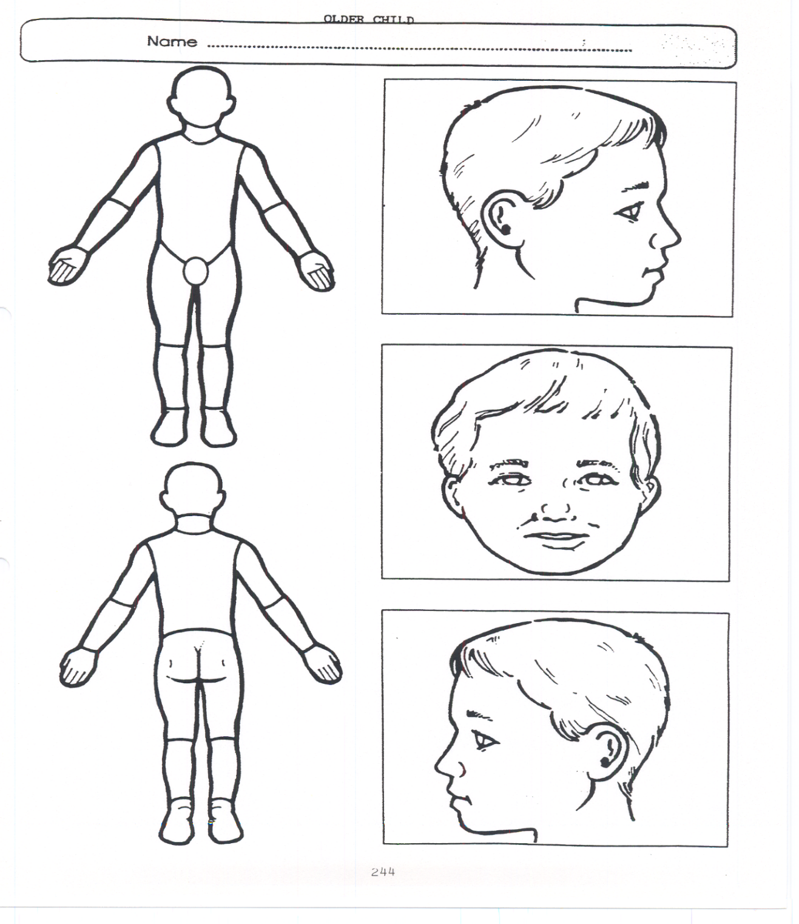

Older Child

Annex 2: SAFEGUARDING INDUCTION SHEET FOR SUPPLY STAFF, VOLUNTEERS AND VISITORS.
We all have a statutory duty to safeguard and promote the welfare of children, and at our school we take this responsibility seriously.

If you have any concerns about a child or young person in our school, you must share this information immediately with our Designated Safeguarding Lead (DSL) or one of the Deputy post holders.

Do not think that your worry is insignificant if it is about hygiene, appearance, or behaviour – we would rather you told us as we would rather know about something that appears small than miss a worrying situation.

If you think the matter is very serious and may be related to child protection, for example, physical, emotional, sexual abuse or neglect, you must find one of the designated professionals detailed below and provide them with a written record of your concern. A copy of the form to complete is attached to this and others can be obtained from the staffroom noticeboard. Please ensure you complete all sections as described.

If you are unable to locate them, ask a member of the school office staff to find them and to ask them to speak with you immediately about a confidential and urgent matter.

Any allegation concerning a member of staff, supply staff, a child’s foster carer or a volunteer should be reported immediately to the Headteacher. Should an allegation be made against the Headteacher, this will be reported to the SET CEO. Alternatively, you can contact the Norfolk Local Authority on 0344 800 8021. NSPCC whistleblowing helpline is also available for staff who do not feel able to raise concerns regarding child protection failures internally. Staff can call: 0800 028 0285 – line is available from 8:00am to 8:00pm, Monday to Friday or via e-mail: help@nspcc.org.uk.

The people you should talk to in school are:
Burston
Designated Safeguarding Lead: Sally Underwood
Location of office: main corridor
Contact number: 01379 7413256

Deputy Safeguarding Lead: Karen Millar
Location of office: Stradbroke High School
Contact number: 01379 384387/07384810456

Deputy Safeguarding Lead: Christine North
Location of office: main office/reception
Contact number: 01379 741256

Tivetshall
Designated Safeguarding Lead: Tom Henry
Location of office: Main corridor
Contact number: 01379 677350

Deputy Safeguarding Lead: Karen Millar
Location of office: Stradbroke High School
Contact number: 01379 384387/07384810456

Deputy Safeguarding Lead: Molly Cattermole
Location of classroom: Elm class
Contact number: 01379 677350

Chair of Trustees: Peter Rout
Contact Number: 01953 609000

Annex 3: LOCAL SAFEGUARDING PROCEDURES

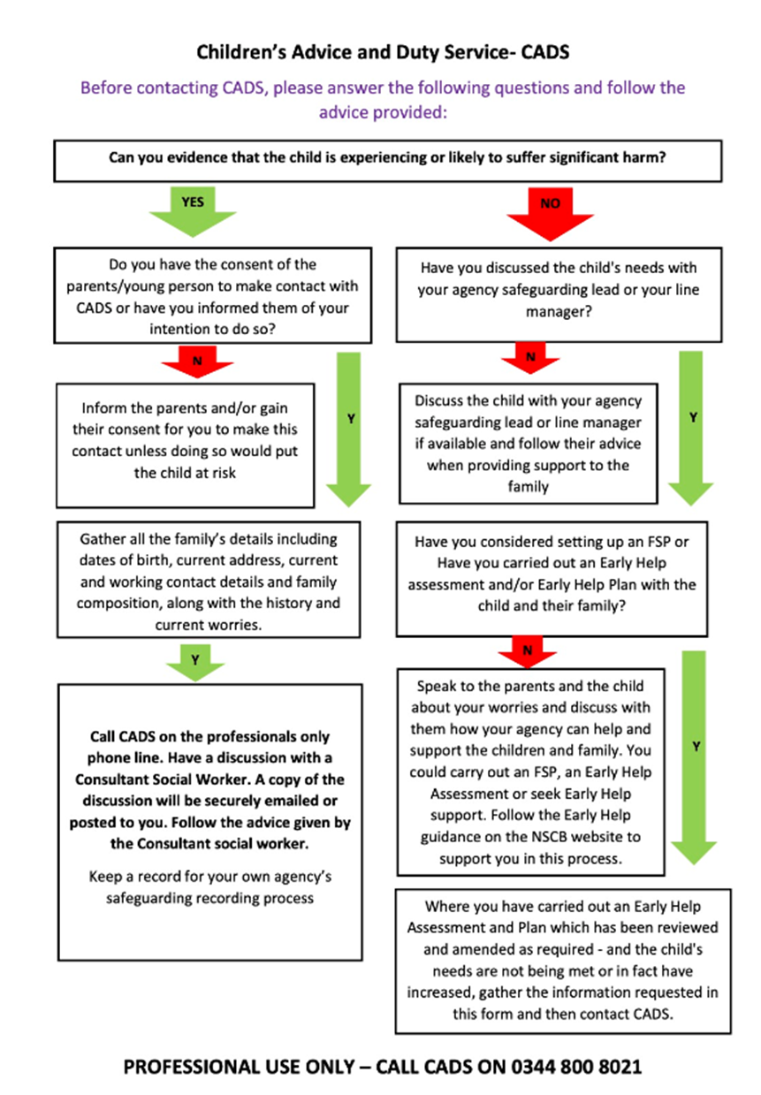

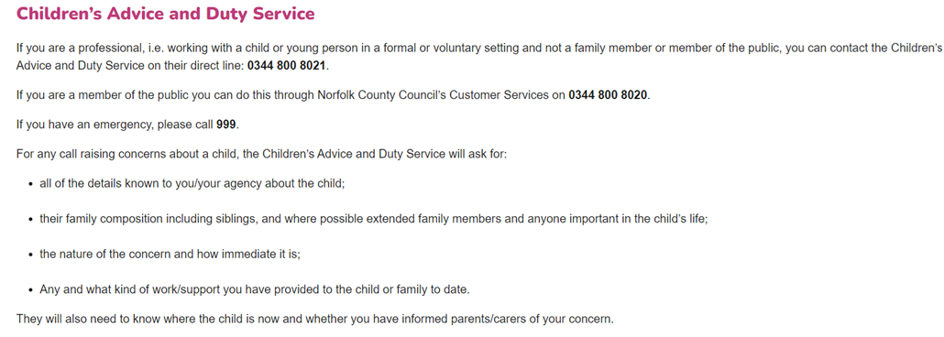

ANNEX 4: MYCONCERN REPORTING SYSTEM

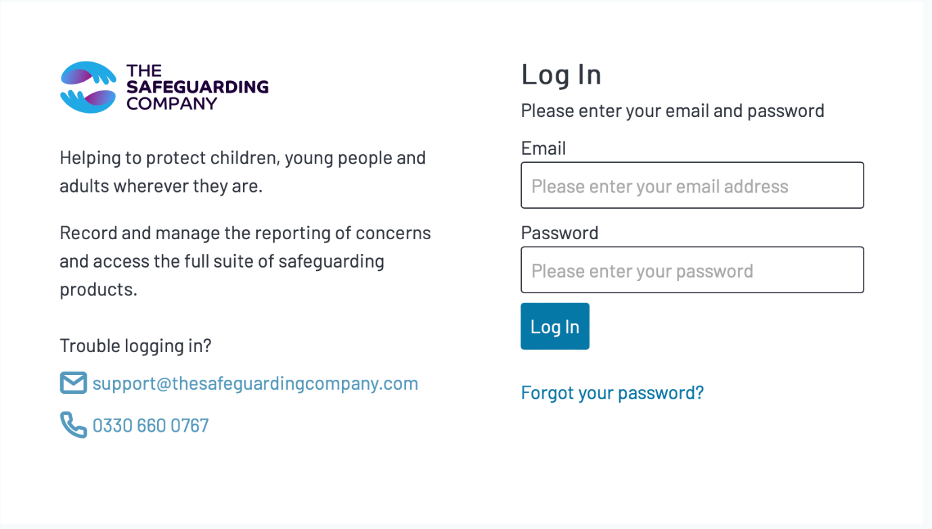

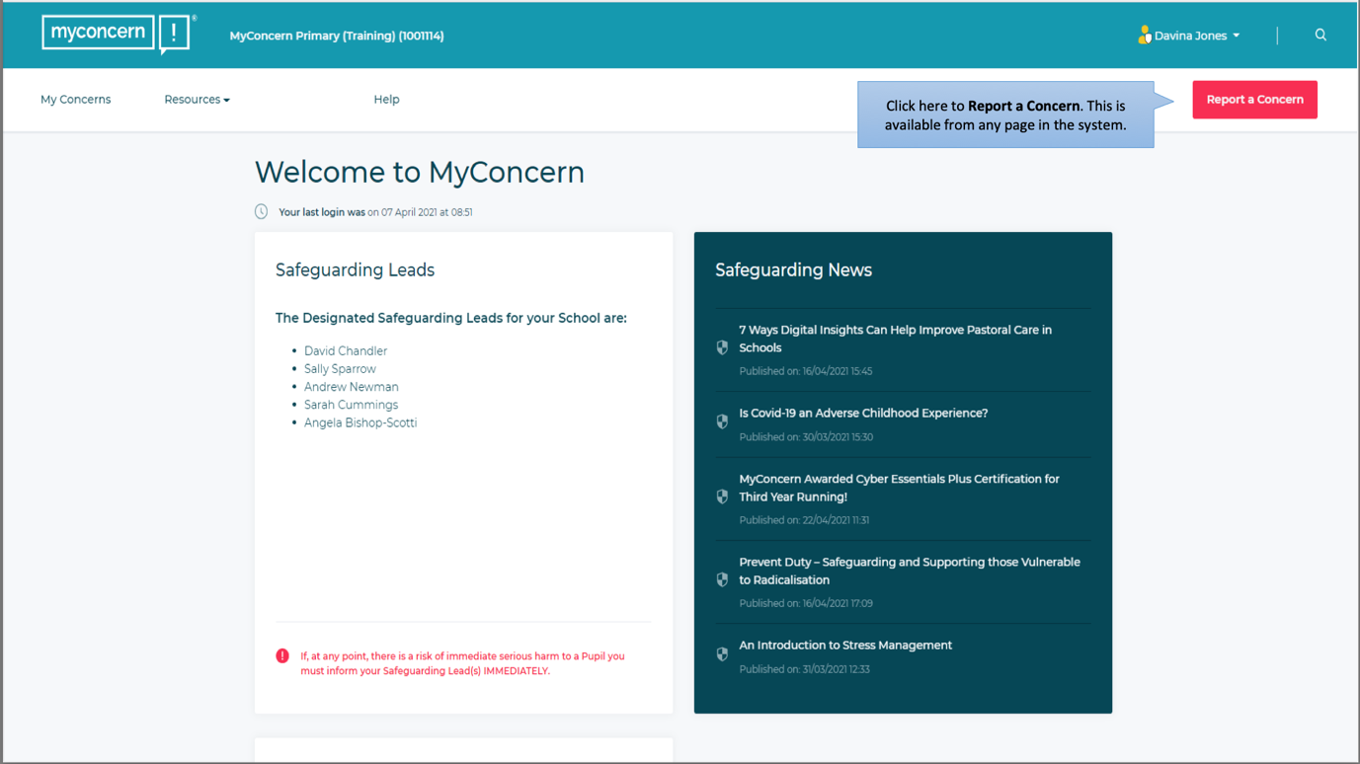

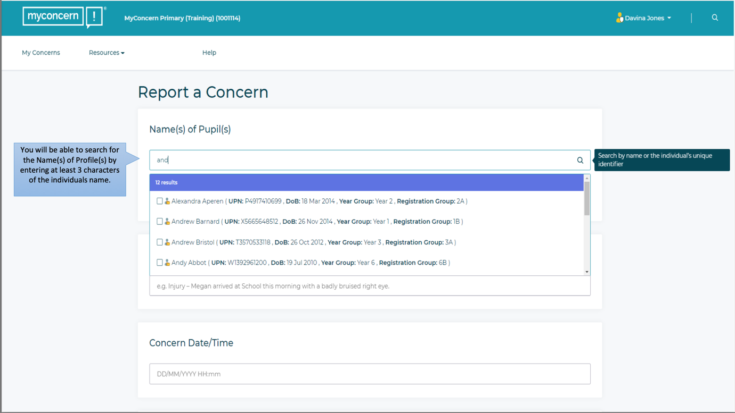

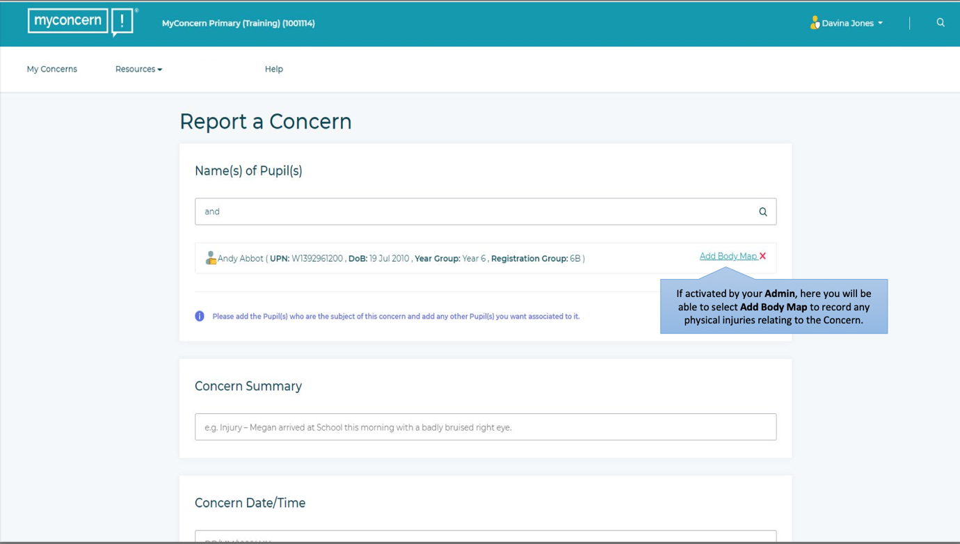

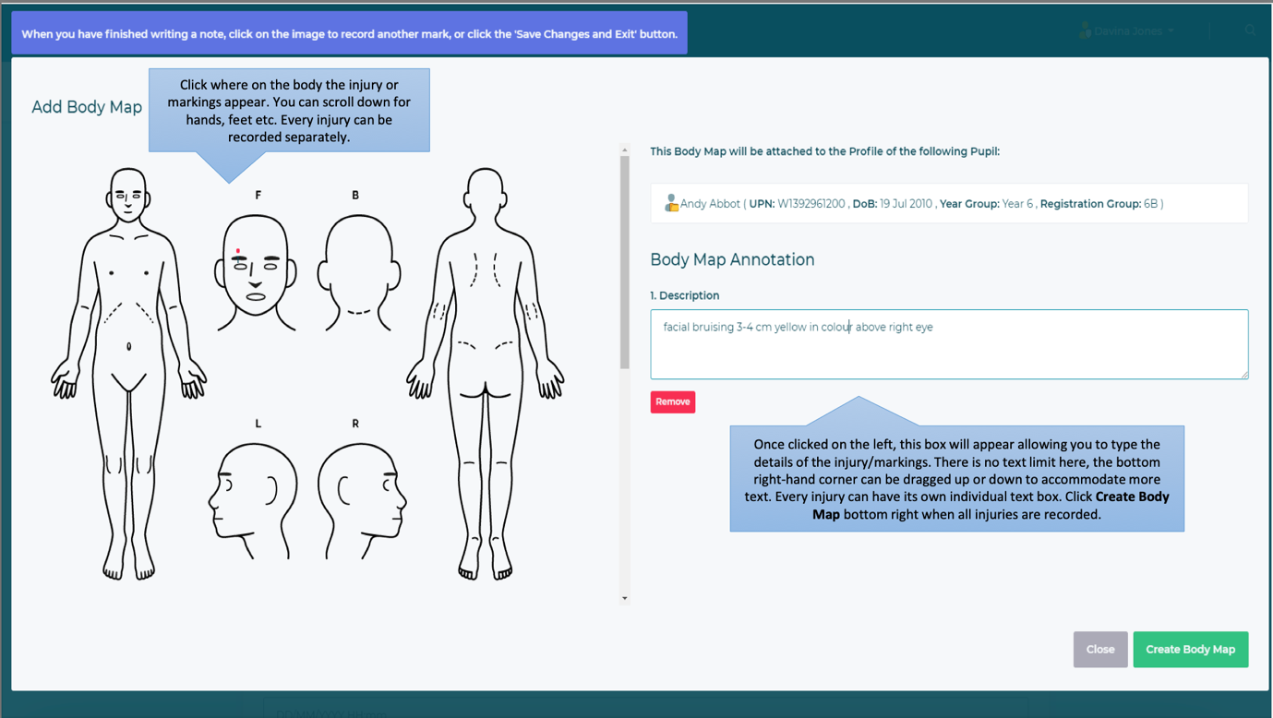

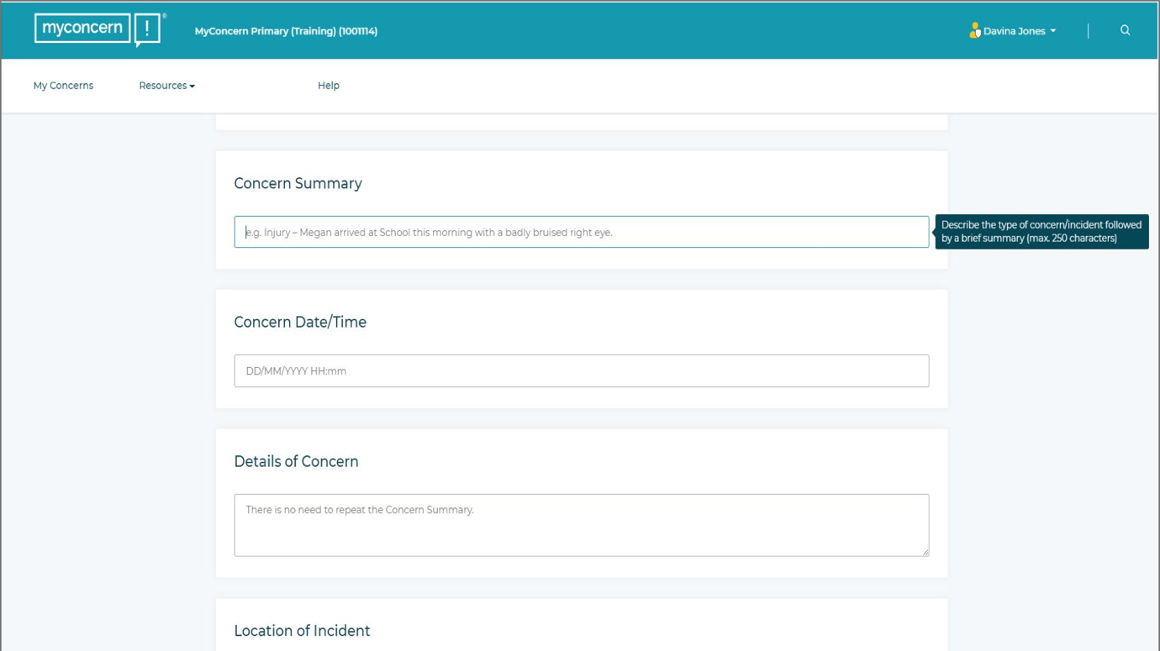
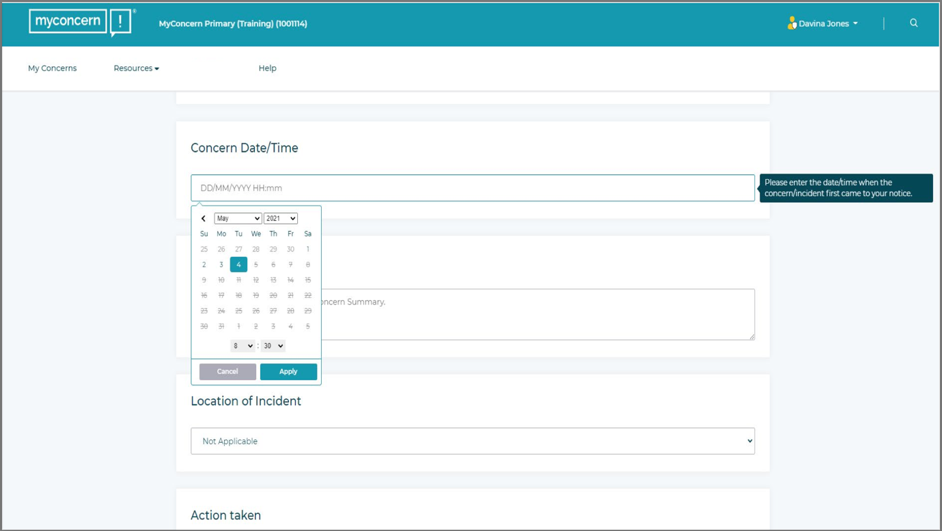

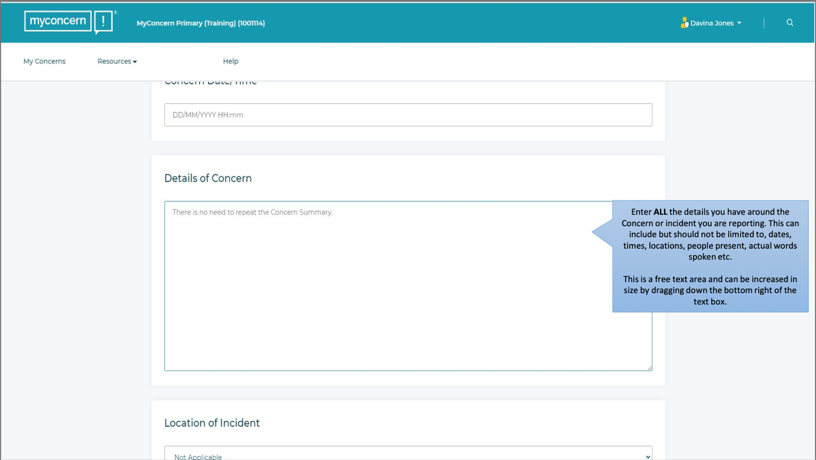

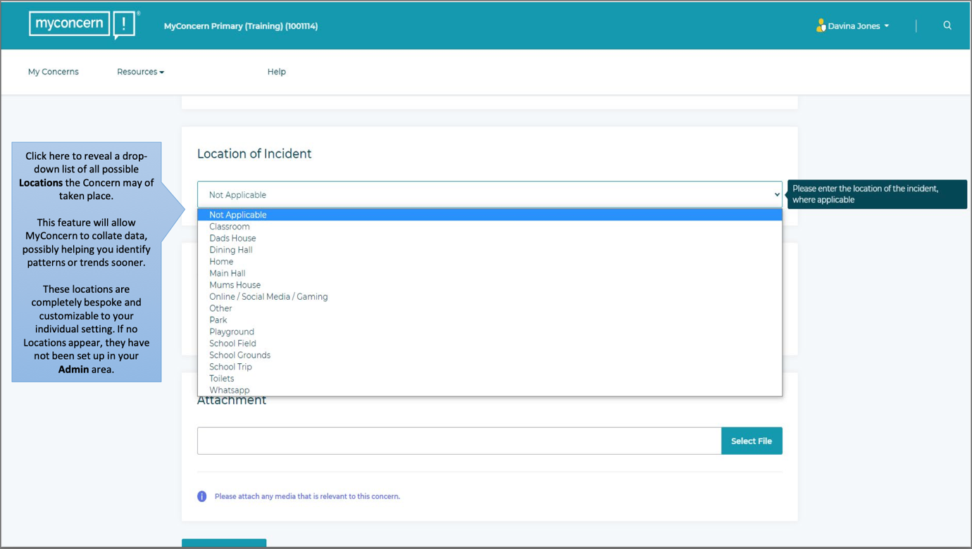

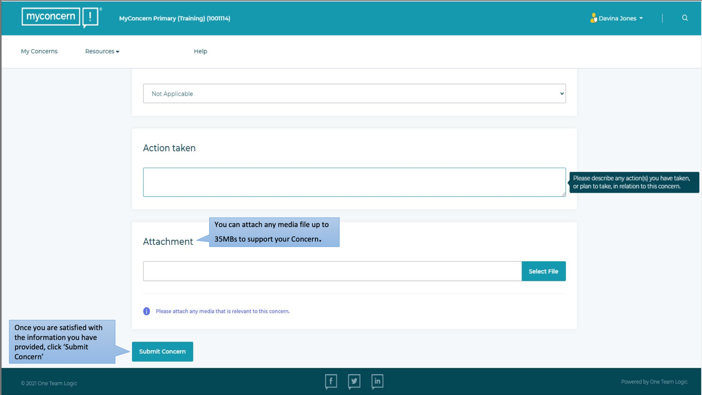

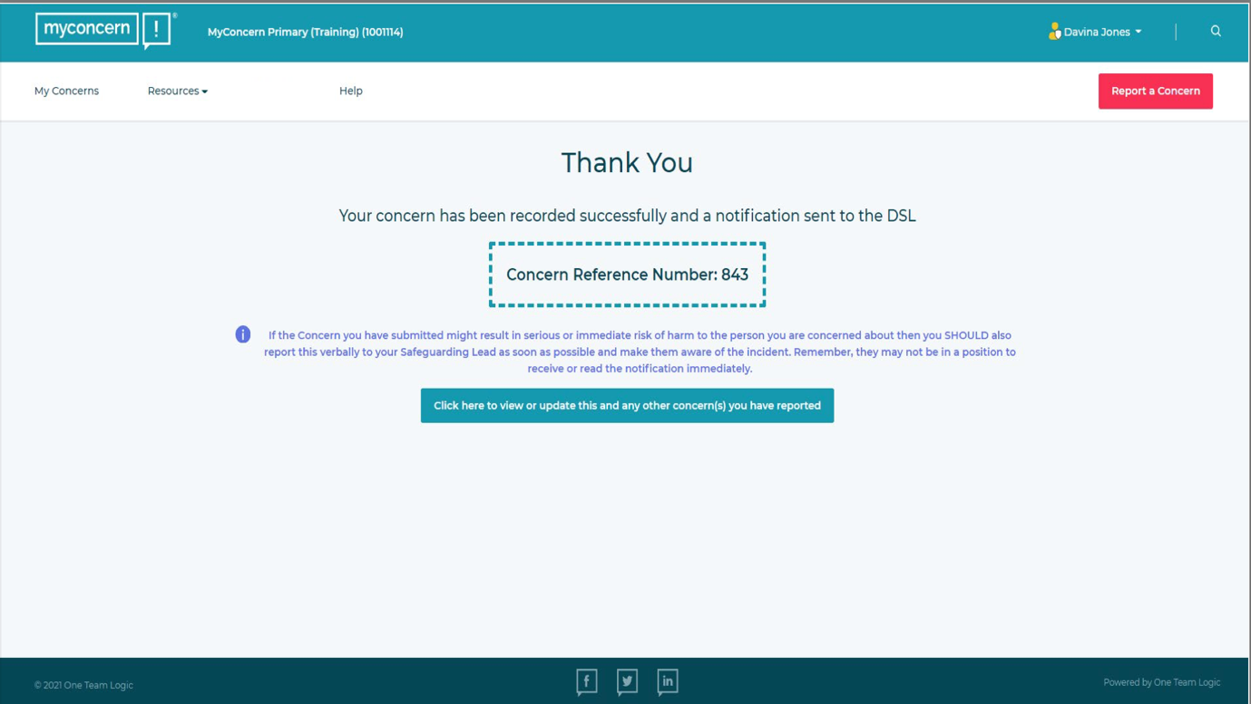

The police caution is: “You do not have to say anything. But it may harm your defence if you do not mention when questioned something which you later rely on in Court. Anything you do say may be given in evidence.”
A person need not be cautioned if questions are for other necessary purposes, e.g.: (a) solely to establish their identity or ownership of any vehicle; to obtain information in accordance with any relevant statutory requirement; in furtherance of the proper and effective conduct of a search, e.g. to determine the need to search in the exercise of powers of stop and search or to seek co-operation while carrying out a search; or to seek verification of a written record.

