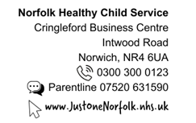

Reception Year Vision and Hearing Screening

The Healthy Child Programme team will also be visiting your child’s school to test the hearing and vision of children during their Reception year. A member of the school staff may be present during screening.

All children are eligible for this service on school entry, including those who wear glasses.

Providing more information about your child before we visit school

Please use the QR code or link below and complete parts 1 & 3 on the form, if your child:-

- Is under regular review at the hospital for ears, eyes or both
- Has additional needs

IMPORTANT INFORMATION – CHILDREN WEARING PROGRAMMABLE SHUNTS

Hearing screening equipment used by us can affect the programmable shunt – it is very important that you opt your child out of school hearing screening if they have one fitted.

Please opt your child out by completing parts 1 & 2 of the online form if they have a programmable shunt fitted.

https://www.justonenorfolk.nhs.uk/our-services/hearing-and-vision-school-screening/




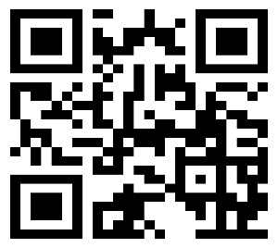

Vision and hearing screening results
- Pass result
You will not receive a results letter if your child passes the screening.
Take your child to see an optician for a vision check when they are 9 Years old.

- Not passed or unable to test
A letter will come home with your child on the day of screening with the results and further information on what happens next.
Your child’s vision and hearing result will be shared with school. If you do not want us to share your child’s vision and or hearing results with the school please contact us by the date shown in the grey box below.

Opting your child out of vision and hearing screening

If you are happy for your child to be screened, you do not need to do anything.

If you do not wish for your child to be screened please follow the steps below in the grey box.
To opt your child out of vison or hearing screening or both please follow the steps below:

- Contact us by Thursday 19th March 2026
- Using the QR code or link – please complete parts 1 & 2 of online opt out form https://www.justonenorfolk.nhs.uk/our-services/hearing-and-vision-school-screening/
- Or call 0300 300 0123
- Leave the following information:-
  - child’s full name
  - NHS Number (if known)
  - date of birth
  - current home address
  - school they attend
  - Your contact information
  - check/test you’re opting them out of

It is very important that we receive all the above information when you are opting your child out.

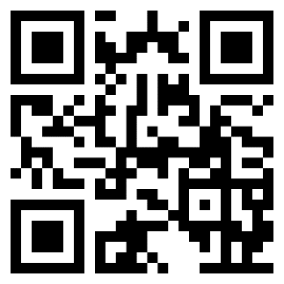

We provide this service to help protect the health of your child as part of our public task as a health service provider. Your child’s school has provided us with your contact details. We will update your child's electronic health record of the outcome of our screening programme.​

https://www.cambscommunityservices.nhs.uk/docs/default-source/ig-privacy-notices/privacy-notice-hcp-may-2022.pdf?sfvrsn=2
If your child misses screening, we may contact you via text message. Please call Just One Number on 0300 300 0123 if you do not want to received text messages from us.
To find out more information about vision and hearing screening and to watch useful videos about the screening please visit - https://www.justonenorfolk.nhs.uk/our-services/hearing-and-vision-school-screening

Please do not hesitate to contact the team if you have any queries.

Yours faithfully,

Norfolk and Waveney Children & Young People’s Health Services

