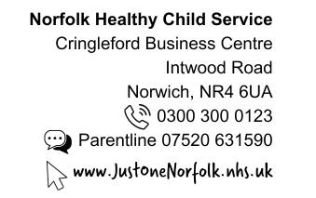

School Height & Weight Check – National Child Measurement Programme (NCMP)

Each year in England, school children in Reception have their height and weight checked at school as part of the National Child Measurement Programme. Height and weight measurements are used to calculate weight status. The information gathered allows services to plan how to support families to lead healthy lives.

Your child’s class will take part in this year’s programme.

The checks are carried out by trained staff from the Healthy Child Programme. Children are measured fully clothed, except for their coats and shoes, in a private space away from other pupils. A member of the school staff may be present during screening.

The programme will be delivered in in line with the school and local authority’s safety control measures. This includes robust hand and respiratory hygiene and enhanced cleaning arrangements for the rooms and equipment used to measure your child’s height and weight as recommended in the national guidance for schools and healthcare settings.

Maintaining the well-being of children in the NCMP

The wellbeing of children and families is very important. Measurements are carried out in a sensitive way, in private and away from other children. Your child’s results are not shared with your child or their school. The weight and height results are only shared with you. It is your choice if you share the information with your child.

The emotional impact of the NCMP has been researched and studies show that body image, self-esteem, weight-related teasing and restrictive eating behaviours do not change as a result of being measured or receiving feedback.

Please see page 2 of this letter on how to opt your child out of these checks.

NCMP results – what happens next:

- Healthy Weight - You will not receive a results letter if your child is in the healthy weight range. You can talk to a member of our team about your child’s height and weight results by contacting us on the details above.

- Underweight - You will receive a letter within 6 weeks with the results and further information.

- Overweight - You will receive a letter within 6 weeks with the results and further information. Your details will be shared with Gro-Health our tier 2 weight management service, and they will contact you directly for continued support.

- Very Overweight - You will receive a letter within 6 weeks with the results and further information. Your details will be shared with Gro-Health our tier 2 weight management service, and they will contact you directly for continued support.

Opting your child out of the National Child Measurement Programme

If you are happy for your child to be measured, you do not need to do anything.

If you do not wish your child’s height and weight to be checked, please follow the steps below in the grey box. Children will not be made to take part if they do not want to.
If you wish to opt your child out of the National Child Measurement Programme (NCMP) please follow the steps below:

- Contact us by Thursday 19th March 2026
- Use the QR code or the link - please complete parts 1 & 2 on the opt out form https://www.justonenorfolk.nhs.uk/our-services/school-height-and-weight-checks/national-child-measurement-programme-ncmp/
- Or call 0300 300 0123
- Leave the following information:-
  - child’s full name
  - NHS Number (if known)
  - date of birth
  - current home address
  - school they attend
  - Your contact information
  - check/test you’re opting them out of
It is very important that we receive all the above information when you are opting your child out.

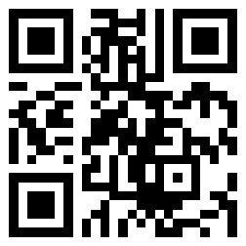

We provide this service to help protect the health of your child as part of our public task as a health service provider. Your child’s school has provided us with your contact details. We will update your child's electronic health record of the outcome of our screening programme.
https://www.cambscommunityservices.nhs.uk/docs/default-source/ig-privacy-notices/privacy-notice-hcp-may-2022.pdf?sfvrsn=2

For information regarding the data collection and how it’s used please see separate attachment – NCMP data collection.

Please do not hesitate to contact the team if you have any queries.

Yours faithfully,

Norfolk and Waveney Children and Young People’s Health Services

