The information we collect and what it is used for is listed below:

- your child’s date of measurement, sex and date of birth are used to calculate your child’s weight category
- your child’s name, date of birth and NHS Number are used to link your child’s measurements in Reception and Year 6. Other data sets held by NHS England and Department of Health and Social Care, may also be linked to allow the addition of information from health and education records, where lawful to do so, to understand how and why the weight of children is changing, and how this affects children’s health and education and how the care children receive can be improved. This includes your child’s health data relating to:
  - their birth, hospital care (including time in hospital and out-patient appointments and diagnosis of medical conditions)
  - mental health
  - social care
  - primary care - includes all healthcare outside of hospital such as GP and dental appointments,
  - public health - including data relating to preventing ill health such as immunisation records
  - records for when and the reason why people pass away
  - medical conditions such as cancer, diabetes
  - health, lifestyle and wellbeing surveys that your child has participated in
- your child’s ethnicity and address are used to help understand some of the reasons for the difference and changes in child weight across England
- your address is required to send you your child’s feedback letter. This will include your child’s measurements together with information about access to our Just One Norfolk website and support pages.
- your email address and telephone number are required as we may contact you by email or telephone to discuss your child’s feedback/ send you your child’s feedback letter by email/ offer you further support following your child’s height and weight measurement.

All the data collected is also used for improving health, care and services through research and planning.

All this information is treated confidentially and held securely. No individual measurements will be given to school staff or other children.

How the data is used

The information collected from all schools in the area will be gathered together and held securely by Cambridgeshire Community Services NHS Trust. We will store your child’s information as part of their local child health record on the NHS’s child health information database and share it with their GP.

All the information collected about your child will be sent by us to NHS England. NHS England is responsible for collecting data and information about health and care so that this can be used to monitor and improve the care provided to people across England.

The information collected about your child will also be shared by NHS England with the Office for Health Improvement and Disparities (OHID) which is part of the Department of Health and Social Care (DHSC) but in a de-personalised form only. This means OHID will not be able to identify your child. OHID focuses on improving the nation's health so that everyone can expect to live more of life in good health, and on levelling up health disparities to break the link between background and prospects for a healthy life.

Both NHS England and the Office for Health Improvement and Disparities (DHSC) will use the information from the National Child Measurement Programme to better understand numbers and trends in child weight and body mass index (BMI). This helps with the planning of services to support healthy lifestyles in your area. No information will ever be published by NHS England or the Office for Health Improvement and Disparities (DHSC) that identifies your child. NHS England use the data to produce National Child Measurement Programme statistics reports showing trends at national and local community level.

De-personalised information from the National Child Measurement Programme may also be shared by NHS England with other organisations, such as universities. This is to help improve health, care and services through research and planning. This information cannot be used to identify your child, and NHS England only ever shares information for research through formal assurance and approvals processes, seeking advice from experts as necessary.

Further information

Further information about the National Child Measurement Programme can be found at https://www.nhs.uk/live-well/healthy-weight/national-child-measurement-programme

Information and fun ideas to help your kids stay healthy can be found at
https://www.nhs.uk/healthier-families/

Another way to help maintain a balanced diet and physical activity for your family is the NHS Healthy Steps email programme. Sign up for the 8-week Healthy Steps emails and you will be sent lots of low-cost easy tips, fun games, healthy swaps and tasty recipes on a budget.

Scan the QR code or visit healthysteps.uk to sign up.
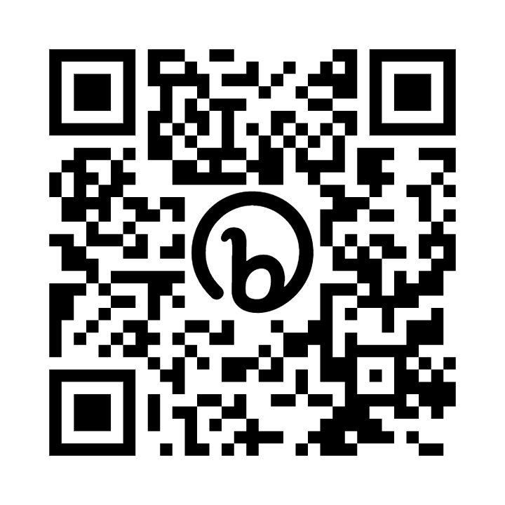

Information about how we Cambridgeshire Community Service NHS Trust collect and use information can be found at https://www.cambscommunityservices.nhs.uk/docs/default-source/ig-privacy-notices/privacy-notice-hcp-may-2022.pdf?sfvrsn=2
Information about how NHS England and Office for Health Improvement and Disparities collect and use information can be found at https://digital.nhs.uk/about-nhs-digital/our-work/keeping-patient-data-safe/how-we-look-after-your-health-and-care-information and https://www.gov.uk/government/organisations/department-of-health-and-social-care/about/personal-information-charter
Information about the organisations NHS England has shared information from the National Child Measurement Programme can be found at https://digital.nhs.uk/services/national-child-measurement-programme

