30th January 2026
Sent via email

Dear Parents/Carers,
We are writing to all parents/carers of pupils across our 22 schools to update you about important changes to the way that Ofsted inspects schools.
Ofsted has introduced a new framework that significantly changes the way schools are inspected and reported on by them. This approach moves away from headline judgements and introduces a report card for all schools. The report card is intended to offer a more balanced picture across a range of areas and is different to Ofsted reports that you may be used to viewing.
One important aspect is that the new framework does not directly compare to judgements previously used by Ofsted. The previous gradings such as Outstanding, Good, Requiring Improvement, or Inadequate no longer exist and it is important that the new report card gradings are not viewed in this way. Ofsted explicitly states that the new framework is not directly comparable to the previous one. We agree with Ofsted’s recommendation that the written report is just as important to consider as the individual report card gradings. When your child’s school is inspected, we would encourage you to look at the narrative as well as the report card findings.
We understand that it may be much more common for areas in a school to be classified as ‘needs attention’ than was previously the case. This reflects the reality that many schools have ongoing priorities and areas of continual focus. This should not be equated with the previous ‘Requires Improvement’ gradings. Ofsted have produced a video for parents to explain the changes, and this is available here; New Ofsted report cards. We have always taken the view that an Ofsted inspection is a short snapshot of a school at a particular moment in time. As a Trust we work continually with our school leaders to provide as high a standard of education as we can, constantly evaluating and developing. We encourage all our Stakeholders to review the new Ofsted framework with a sense of proportionality. Ofsted has a role

to play alongside parents/carers, staff and pupil feedback, and our ongoing work reviewing standards. We wanted to share the changes with you ahead of any of our schools being inspected to raise awareness with you of the changes that Ofsted have made.
May we take this opportunity to thank you for your continued and ongoing support.

Yours Sincerely,
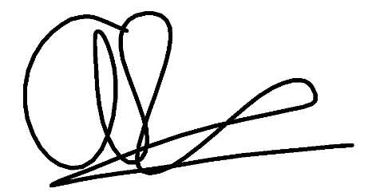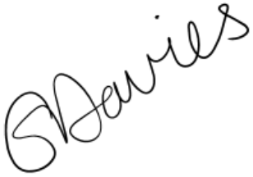

Andrew Robinson Emma Davies
Deputy Chief Executive Officer Deputy Chief Executive Officer

