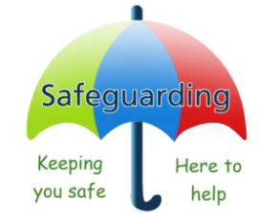 |  |  |  |  | KEEPING CHILDREN SAFE —what you need to know
A child means everyone under the age of 18.   |  | Children need the right help at the right time to address risks.  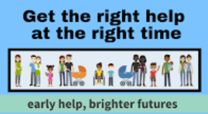 |  |  |  |  | Remember “it could happen here” where safeguarding is concerned.   |  |  |  | We are all responsible for the welfare of children and keeping the environment safe, whatever our job.  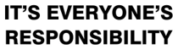
What is safeguarding?
Safeguarding and promoting the welfare of children is defined for the purposes of KCSiE, 2026 as:
• providing help and support to meet the needs of children as soon as problems emerge,
• protecting children from maltreatment, whether that is within or outside the home, including online,
• preventing the impairment of children’s mental and physical health or development,
• ensuring that children grow up in circumstances consistent with the provision of safe and effective care, and
• taking action to enable all children to have the best outcomes.
What do I need to do?
ALWAYS ACT  in the best interests of the child. Never promise confidentiality. |  |  |  |  |  | KNOW HOW  to identify children who may benefit from early help |  |  |  |  | KNOW THE DIFFERENT  types of abuse and neglect, so that you can identify children who may be in need of help or protection
Know what to do if a child tells you they are being abused or neglected……….   |  |  |  |  |  |  | Know who the Designated Safeguarding Lead & Deputies are, talk to them as soon as you are concerned.  
Designated Safeguarding & Prevent Lead: Mr Tom Henry
Deputy Safeguarding Leads: Mrs Karen Millar & Mrs Molly Cattermole
Online Safety Lead: Mr Tom Henry Designated Teacher for Children in Care: Mr Tom Henry
 | All staff must read and sign for Keeping Children Safe in Education, Safeguarding/Child Protection Policy & Whistleblowing Policy. |  |  |  |  |  | If a teacher finds that FGM appears to have been carried out on a girl under the age of 18, they must call the police. |  | 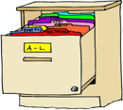 |  |  | All concerns, discussions and decisions made must be recorded and stored securely.
Staff Behaviour  If you are concerned about the behaviour of any staff member, member of SET staff, trustee, or visitor you should speak to the Headteacher/DSL.  Concerns about the Headteacher should be referred to the CEO of the Trust. |  |  |  |  |  |  | Whistleblowing  If you are worried about poor or unsafe safeguarding practices or potential failures in the school, you should talk to the Headteacher or CEO. You could also contact the Whistleblowing Advice Line (0800 0280285 or help@nspcc.org.uk) for advice and support
 |  |  |  | School Road, Tivetshall St Mary, NR15 2BP  Tel: 01379 677350  Email: office@tps.set.education  Website: www.stradbrokehigh.co.uk |  |  |  |  |  | 

