

Safeguarding at Burston Primary School
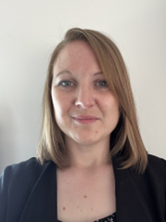
Miss Sally Underwood,
Head of School / Designated Safeguarding Lead
s.underwood@bps.set.education
01379 741256
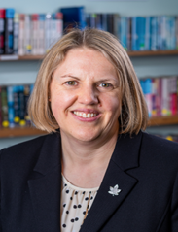 | Mrs Karen Millar  Executive Headteacher  Deputy Safeguarding Lead  k.millar@shs.set.education  01379 384387 / 07384810456
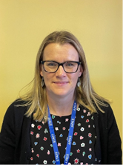 | Mrs Christine North  Deputy Safeguarding Lead  c.north@bps.set.education  01379 741256

This school has a Safeguarding Policy

- All visitors will be asked to sign in and wear a visitor’s badge.

- Visitors may be approached within school to confirm their identity.

- Visitors who are not here on school business will be asked to leave the premises.

Thank you for your understanding and co-operation.

THE DESIGNATED SAFEGUARDING LEAD (DSL) IS:
Sally Underwood

Deputy DSL’s are:
Karen Millar
Christine North

